THE UNITED REPUBLIC OF TANZANIA
PRESIDENT’S OFFICE
REGIONAL ADMINISTRATION AND LOCAL GOVERNMENT

KIGOMA REGION
FORM SIX JOINT PRE-NATIONAL EXAMINATION
MUYOVOZI NYARUBANDA MNANILA MWANDIGA BOGWE KIBONDO AMANI MTENDELI MKUGWA MALAGARASI KAKONKO

131/3A PHYSICS 3A
Time: 3:20Hours April, 2025
Instructions.
- This paper consists of three (3) questions.
- Answer all questions
- All working must be shown clearly on how you arrived at the answer 4. Write your examination number on every page of your answer booklets.
5. The following information’s may be useful:
- Acceleration due to gravity
- Specific heat capacity of copper calorimeter 𝐶_{𝐶} = 0.385𝐽𝑔⁻¹𝐶⁻¹
- Specific heat capacity of water 𝐶_{𝑤} = 4.184𝐽𝑔⁻¹𝐶⁻¹

of
1. You are provided with retort stand, a thread, a pendulum bob, cork pards, stop watch and meter rule.
Proceed as follows
- Set the length of a given thread and its pendulum bob to have 50cm from the point of suspension as shown in figure below, the pendulum bob must be just above surface of the table to allow swinging of the bob for ℎ = 1𝑐𝑚



Retort stand

Thread

bo
b

h

TABLE

- Displace a bob in a small angle and then release it to initiate free oscillations.
- Using stop watch provided measure and record the time for 20 oscillations
- Repeat the procedures above using ℎ = 10𝑐𝑚, 20𝑐𝑚, 30𝑐𝑚 𝑎𝑛𝑑 40𝑐𝑚, record the corresponding time for 20 oscillations for each value of ℎ.
Questions
i. Tabulate results ii. Derive an expression that govern this experiment.
iii. Plot a graph of ℎ against 𝑡². iv. Determine slope (S) of your graph.
- Record the vertical intercept of your graph.
- State the physical meaning of answer obtained in (v) above. vii. Calculate the value of Q, from 𝑄 = −4𝜋²𝑛²𝑆.
viii. What is physical meaning of Q.

2. The aim of this experiment is to determine the specific heat capacity of solid brass by the method of mixture.
Proceed as follows
- Set up the apparatus as shown below.

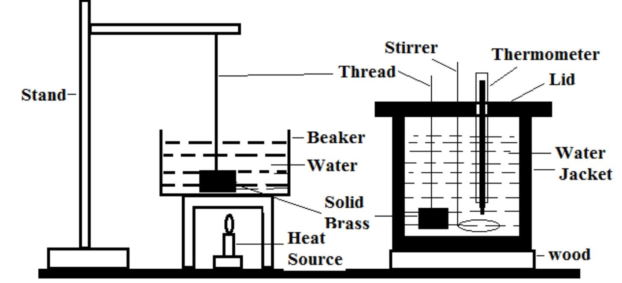
figure 2
- Heat up the solid brass on beaker containing some water to about 90⁰C. Use a piece of thread to suspend the solid from retort stand as shown in figure 2
above, then record temperature of boiling point of water as initial temperature of solid brass 𝜃₁ = 90⁰𝐶
- Meanwhile,
  - Determine the mass 𝑀_{𝑐} of the calorimeter when empty and two-third filled with cold water then calculate mass of cold water 𝑀_{𝑊}
  - Place the calorimeter two-third filled with cold water in the calorimeter jacket. Measure the initial temperature of the cold water 𝜃₀
  - Quickly transfer the solid brass into the calorimeter and cover it with lid to minimize heat losses as indicated in figure 2 above, stir well and record the equilibrium temperature 𝜃_{𝑒𝑞}
  - Remove the solid from the calorimeter and measure its mass 𝑀_{𝑆}
- Apply the method of mixtures show how you can find the specific heat capacity of solid brass 𝐶_{𝑠} then calculate its value.
- State one possible sources of error in this experiment and how to minimize it.

3. The aim of this experiment is to determine the value of unknown resistance S by using the meter bridge.
Proceed as follows
      - You are provided with one dry cell, a switch K, a resistance box R, metre bridge, a standard resistor ‘S’ of unknown resistance, a galvanometer G, a jockey J and some connecting wire.
      - Connect the circuit as shown in the diagram below
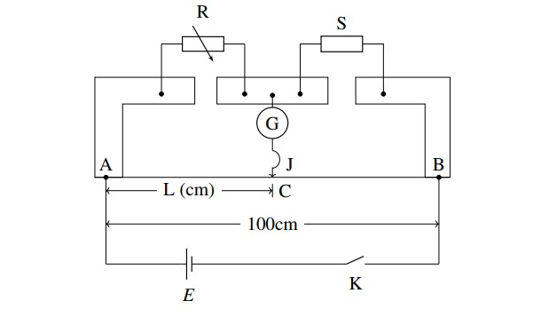
      - Starting with R=5Ω, find the balance length AC=L along the meter bridge wire AB.
      - Repeat the procedures in (iii) above for other values of R obtained by increasing in steps of 5Ω up to R= 30Ω.
      - (a) Tabulate the values of R(Ω), L(cm), ¹ (Ω⁻¹) and ¹ (cm⁻¹)
𝑅 𝐿
1 1
        - Plot the graph of against
𝑅 𝐿
1
        - Evaluate the slope and intercept of the best line.
𝑅
1 100 1 1
        - If = ( ) − , use your results in (C) above to determine
𝑅 𝑆 𝐿 𝐿
average value of unknown resistance S.
        - Identify two possible sources of errors in this experiment.

