
THE PRESIDENT OFFICE
REGIONAL ADMINISTRATION AND LOCAL GOVERNMENT
LULUMBA SECONDARY SCHOOL
FORM ONE MID -TERM EXAMINATION ASSESSMENT
061 COMMERCE
Time: 2:30 Hours Year: August 2023

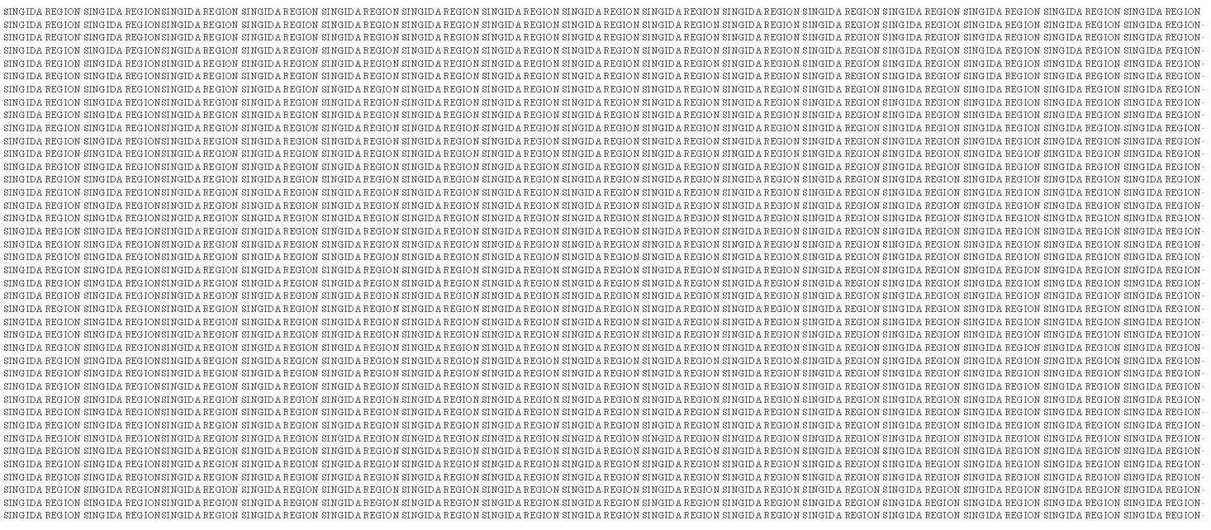


Student Name:……………………………..……………………… Class:…………………………
Instructions
- This paper consist of sections A, B and C with total of ten (10) questions
- Section A and C carries fifteen (15) marks each and section B carries Seventy (70) marks.
- All answers must be written in the spaces provided
- All communication devices, calculators and any unauthorized materials are not allowed in the assessment room
SECTION A (15 Marks)
- For each of the following items (i) –(x), choose the correct answers from the given alternatives and write its letter in the space box provided.
- An itinerant trader who buys and sale one product from only one manufacturer is called? A) Monger B) Single shop C) Tied shop D) Road side traders { }
- A reward for labour is called; { }
A) Rent B) Wages C) Profit D) Interest
- If Juma has been buying cotton from Tanzania and sale them to China, in which trade did Juma involve? { }
A) Import trade B) Export trade C) Foreign trade D) Home trade
- Imagine your father deals with distribution and exchange of goods and services. Which type of activity is conducted by your father among the following; { }
A) Warehousing B) Insurance C) Trade D) Commerce
- A person who organizes other factors of production is called; { }
A) Labour B) Employees C) Entrepreneurs D) Producers
- A kind of labour which requires more physical efforts than mental effort is called { }
A) Skilled labour B) Unskilled labour C) Semi – Skilled labour D) Labour
- Cost which change with level of output is known as; { }
A) Variable cost B) Total C0st C) Fixed Cost D) Average cost { }
- Which of the following indicate a correct stage of production; { }
A) Primary, Secondary and Tertiary B) Secondary, Tertiary and Primary
C) Tertiary, Primary and Secondary D) Primary, Tertiary and Secondary
- Any intangible item which has a market value and utility is called; { }
A) Goods B) Service C) Utility D) Good and Service
- …………….. deals with distribution and exchange of goods and services; { }
A) Production B) Trade C) Commerce D) Business
Answers
- Match the meaning of stock levels terminologies in List A with the relevant terminology in List B by writing the letter of the correct terminology below the corresponding item number in the table provided.
LIST A | LIST B
- The buying of goods and services from other country  - The buying of goods and services within a country  - The buying and selling of goods between two countries  - The buying and selling of goods among the countries  - Means re – exportation of goods and services to another country | - Trade  - Export trade  - Import trade  - Domestic Trade  - Bilateral trade  - Extreport trade  - Retail trade  - Foreign trade
Answers
List A
List B

SECTION B (70 Marks)
Answer all questions.
- Briefly explain the difference between the following terms as used in commerce;
- Utility
- Retailers
- Commerce
- Warehouse
- Itinerant traders
- Joshua is among of form one student studying at Kinambeu Secondary School where they do not study commerce, but he desires to understand how commerce is divided. Now since you have basic commercial knowledge use a diagram to present how commerce is divided.
- In facts we have some small scale retailers who normally sale Ice-cream, Bites, groundnuts, Drinks and food at our school. Now name any five benefit that you get from their business
- (a) Define production
- Name any three levels of production
- Define risk and name any five examples of risks associated with trade
- There are different activities which facilitate business to run smoothly. Name any five of them
- Careful study the following data and then perform necessary calculations
Output | FC | VC | TC | ATC | AVC | AFC
2 | 1,000 | (i) | 10,000 | 5,000 | 4,500 | (ii)
6 | (iii) | 5,000 | 6,000 | (iv) | 125 | 250
8 | 1,000 | 4,000 | 14,000 | 175 | (v) | 125

SECTION C (15 Marks)
Answer this questions which is in easy form
- In our country we have a large number of retailers who sale their products to us, but not all of them are good retailer. Justify this statement by explaining any five criteria for a good retailer
Form one midterm examination assessment (August 2023)
Marking scheme
- In this question student (10, 1@item)
C | B | B | D | C | B | A | A | B | C

- In this question students were required to match the items in list A and B (10, 1@item)
C | D | E | H | F
- In this question students were required to define the following terms (10, 2@item)
- Utility: Means ability of goods and services to satisfy human wants and needs
- Retailer: This is any person who conduct a retail trade such as mongers, Road side traders, Peddlers, Second hand dealers etc
- Commerce: Means the study of exchange and distribution of goods and services so as to satisfy human needs and wants
- Warehouse: Means a large building where goods are being stored while waiting for sale or consumption(using them)
- Itinerant traders: Are those traders who do not have a permanent place for conducting their business such as street vendors, road side traders, mongers, automatic vending machine etc
- This question students were required o draw a commerce flow chart (10, 0.6@item)
- In this question students were required to identify any five benefit associated with retailers (10, 2@item)
- They helps us to get our basic needs
- They create employment opportunity to us
- They provide a convenience means of buying of goods and services, because students can easily have access to goods and services needed
- They provide us with credit facilities
- They are sources of income to the government
- It reduce absentees at school, thus it helps students to settle at school
- a) Production: Means creation of goods and service needed to satisfy human wants and needs. or It deals with transformation of state of raw materials into finished goods needed for satisfying human wants and needs (4 Marks)
b) Three levels of production are
1st Primary level of production (2 Marks)
2nd Secondary level of production (2 Marks)
3rd Tertiary level of production (2 Marks)
- Risk means any unexpected event which has negative impacts in business operations
Examples of risks
- Fire
- Accidents
- Loss
- Bad debts
- Draught
- Thefts
- In this question students were required to name any five Aids to trade .
(10Marks, 0.6@item)
- Transportation
- Banking
- Insurance
- Warehousing
- Advertising
- Communication
- Careful study the following data and then perform necessary calculations
(10Marks, 2@item)
Output | FC | VC | TC | ATC | AVC | AFC
2 | 1,000 | 900 | 10,000 | 5,000 | 4,500 | 5,000
6 | 1,000 | 5,000 | 6,000 | 1,000 | 125 | 250
8 | 1,000 | 4,000 | 14,000 | 175 | 500 | 125

- In this question students were required to identify any five qualities of a good retailers (15Marks, 3@item)
- A good retailer should be smart, but not dirt
- A good retailer should be a good buyer
- A good retailer should use polite language while dealing with customers
- A good retailer should be a good keeper of his/her financial records of the business
- A good retailer should have a financial discipline
- A good retailer should be a good manager of his/her workers
- A good retailer should have a business plan

