
THE PRESIDENT OFFICE
REGIONAL ADMINISTRATION AND LOCAL GOVERNMENT
LULUMBA SECONDARY SCHOOL
FORM ONE MID -TERM EXAMINATION ASSESSMENT
061 COMMERCE
Time: 2:30 Hours Year: Nov 2023

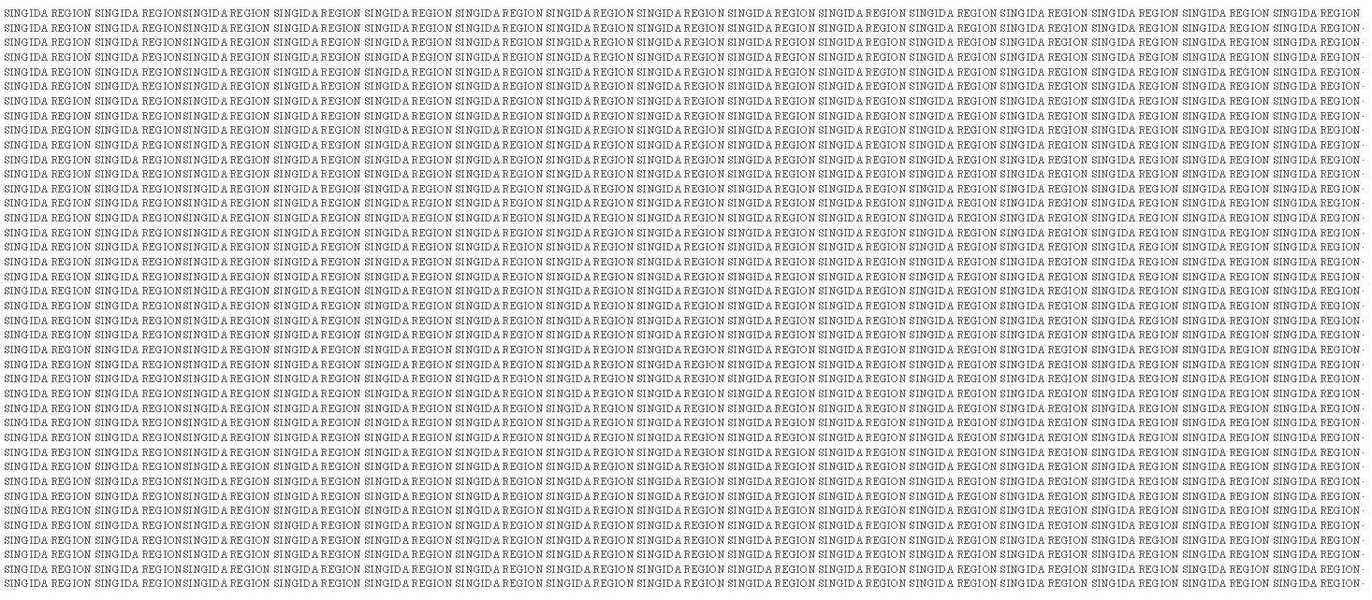


Student Name:……………………………..……………………… Class:…………………………
Instructions
- This paper consist of sections A, B and C with total of ten (10) questions
- Section A and C carries fifteen (15) marks each and section B carries Seventy (70) marks.
- All answers must be written in the spaces provided
- All communication devices, calculators and any unauthorized materials are not allowed in the assessment room
SECTION A (15 Marks)
- For each of the following items (i) –(x), choose the correct answers from the given alternatives and write its letter in the space box provided.
- Madam Jamila has been cooking and selling food to the students, in which type of distribution is she involved? { }
- Zero stage channel (B) One stage channel
(C) Two stage channel (D) Three stage channel
- From the following list who is a final user of goods and services? { }
(A) Distributor (B) Retailer (C) Manufacturer (D) Consumer
- An agent who brings contractual relationship between buyer and seller is known as? { }
- Commission agent (B) Factors (C) Broker (D) Del - cledere agent
- A reward for capital is called; A) Rent B) Wages C) Profit D) Interest { }
- If Yese Monga decide to buy Cement from Dodoma and sale them at Kiomboi, in which trade will Yese be involved? { }
- Domestic trade B) Export trade C) Foreign trade D) International trade
- Which of the following term refers to the path through which goods are passed from producers to consumers? { }
(A) Communication channel (B) Distribution channel
(C) Transportation ways (D) Advertisement channel
- A person who organizes other factors of production is called; { }
A) Labour B) Employees C) Entrepreneurs D) Producers
- Shoes, bags, books, pencils, hoes, computers etc are examples of; { }
A) Product B) Service C) Utility D) Goods
- Means creation of goods or services in order to satisfy human wants and needs { }
- Production (B) Commerce (C) Consumption (D) Industries { }
- An act of selling of goods to the final consumers is called; { }
A) Retail trade B) Retailing C) Wholesale trade D) Wholesaling

- Match the meaning of stock levels terminologies in List A with the relevant terminology in List B by writing the letter of the correct terminology below the corresponding item number in the table provided.
LIST A | LIST B
- A self-service retail stores  - Traders who move from one place to another searching for customers  - Number of shops under one roof which are owned by one person selling different products  - Retail shops under one ownership selling similar class of goods  - Always sells goods in larger quantities to traders | - Wholesalers  - Retailers  - Itinerant trader  - Street traders  - Super market  - Departmental store  - Multiple shops  - Hypermarket

SECTION B (70 Marks)
Answer all questions.
- Briefly explain the difference between the following terms as used in commerce;
- Home trade and Foreign trade
- Trade and AIDS to Trade
- Direct production and Indirect production
- Import trade and Export trade
- Commerce and Business
- With examples, explain different commercial activities carried out in your community.
- (a) Define goods
- Name five examples of goods
- (a) Define retailer
(b) Outline any five qualities of good retailers
- (a) Define factors of production
(b) As an expert of production, briefly, name all major factors which are employed in production process.
- Singida Sunflower Mill Co.LTD has a fixed cost of Tshs. 2,500,000/= and total cost of Tshs. 4,850,000/=
Required:
- By using vivid examples, differentiate between fixed cost and variable cost
- Calculate the company’s variable cost.
- With an aid of diagram present commerce flow chart

SECTION C (15 Marks)
Answer this questions which is in easy form
- In our country we have a large number of small scale retailers who are facing several challenges in their businesses, since you have commercial knowledge explain any five challenges facing them

Form one midterm examination assessment (August 2023)
Marking scheme
- In this question student (10, 1@item)
C | B | B | D | C | B | A | A | B | C

- In this question students were required to match the items in list A and B (10, 1@item)
C | D | E | H | F
- In this question students were required to define the following terms (10, 2@item)
- Utility: Means ability of goods and services to satisfy human wants and needs
- Retailer: This is any person who conduct a retail trade such as mongers, Road side traders, Peddlers, Second hand dealers etc
- Commerce: Means the study of exchange and distribution of goods and services so as to satisfy human needs and wants
- Warehouse: Means a large building where goods are being stored while waiting for sale or consumption(using them)
- Itinerant traders: Are those traders who do not have a permanent place for conducting their business such as street vendors, road side traders, mongers, automatic vending machine etc
- This question students were required o draw a commerce flow chart (10, 0.6@item)
- In this question students were required to identify any five benefit associated with retailers (10, 2@item)
- They helps us to get our basic needs
- They create employment opportunity to us
- They provide a convenience means of buying of goods and services, because students can easily have access to goods and services needed
- They provide us with credit facilities
- They are sources of income to the government
- It reduce absentees at school, thus it helps students to settle at school
- a) Production: Means creation of goods and service needed to satisfy human wants and needs. or It deals with transformation of state of raw materials into finished goods needed for satisfying human wants and needs (4 Marks)
b) Three levels of production are
1st Primary level of production (2 Marks)
2nd Secondary level of production (2 Marks)
3rd Tertiary level of production (2 Marks)
- Risk means any unexpected event which has negative impacts in business operations
Examples of risks
- Fire
- Accidents
- Loss
- Bad debts
- Draught
- Thefts
- In this question students were required to name any five Aids to trade .
(10Marks, 0.6@item)
- Transportation
- Banking
- Insurance
- Warehousing
- Advertising
- Communication
- Careful study the following data and then perform necessary calculations
(10Marks, 2@item)
Output | FC | VC | TC | ATC | AVC | AFC
2 | 1,000 | 900 | 10,000 | 5,000 | 4,500 | 5,000
6 | 1,000 | 5,000 | 6,000 | 1,000 | 125 | 250
8 | 1,000 | 4,000 | 14,000 | 175 | 500 | 125

- In this question students were required to identify any five qualities of a good retailers (15Marks, 3@item)
- A good retailer should be smart, but not dirt
- A good retailer should be a good buyer
- A good retailer should use polite language while dealing with customers
- A good retailer should be a good keeper of his/her financial records of the business
- A good retailer should have a financial discipline
- A good retailer should be a good manager of his/her workers
- A good retailer should have a business plan

