PRESIDENT’S OFFICE
REGIONAL ADMINISTRATION AND LOCAL GOVERNMENT
KIBAHA TOWN COUNCIL
NYUMBU SECONDARY SCHOOL
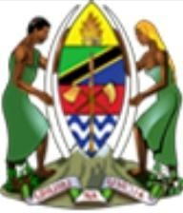
FORM ONE MIDTERM EXAMINATION 2024
041 BASIC MATHEMATICS
Time: 1:30 Hours Year: March 2024
INSTRUCTIONS
- This paper consists of total of ten (10) questions.
- Answer all questions. .
- All necessary working and answers for each question attempted must be shown clearly.
- Write your Examination Number on every page of your answer sheet(s).

- (a) Rearrange the order of the digit in the 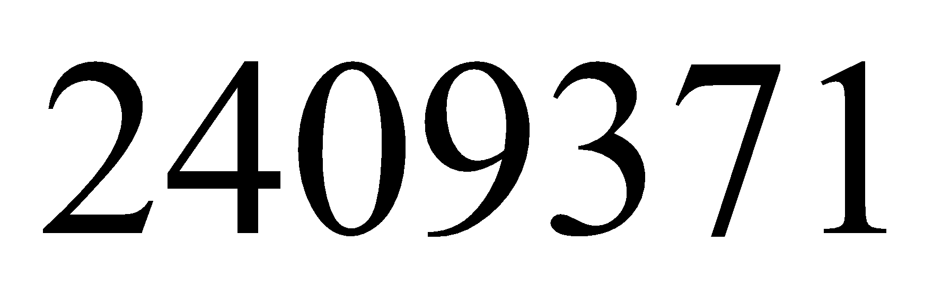 to get
    - The highest number
    - The lowest number
  - Write the 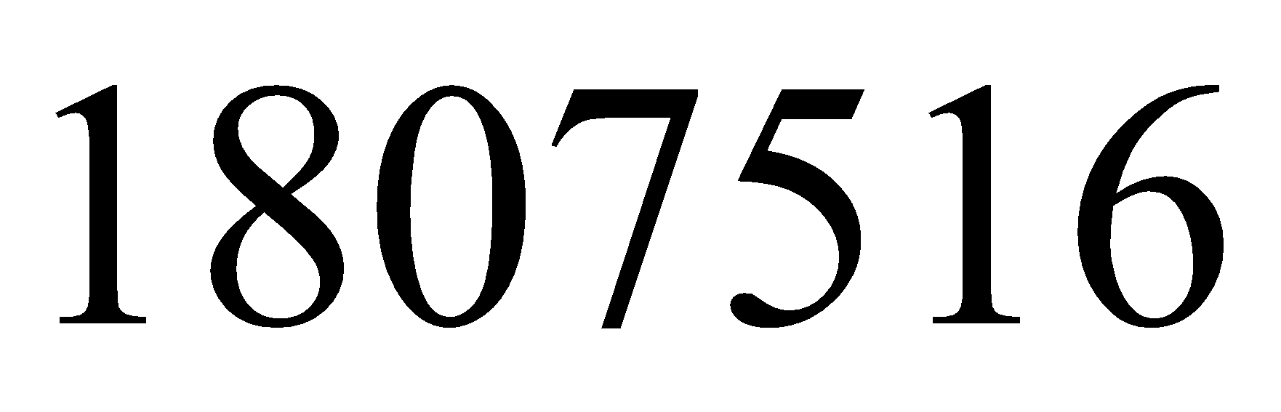 by words
- (a) Write the following number in expanded form
(i) 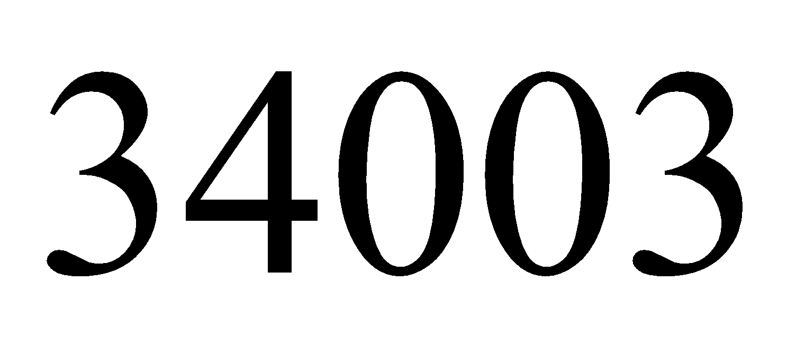
(ii) 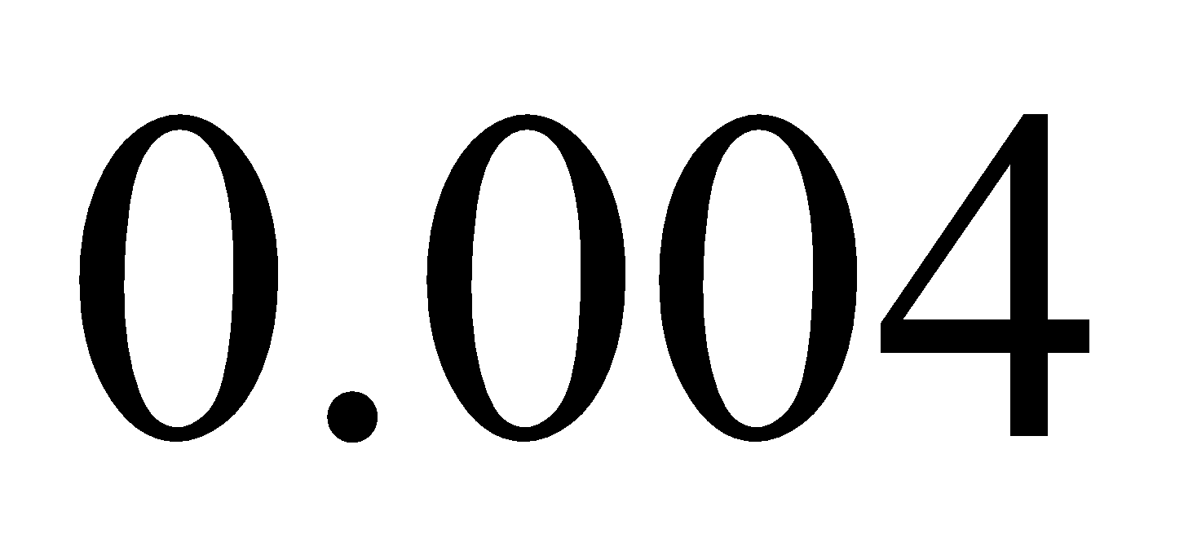
  - Place value each digit in the 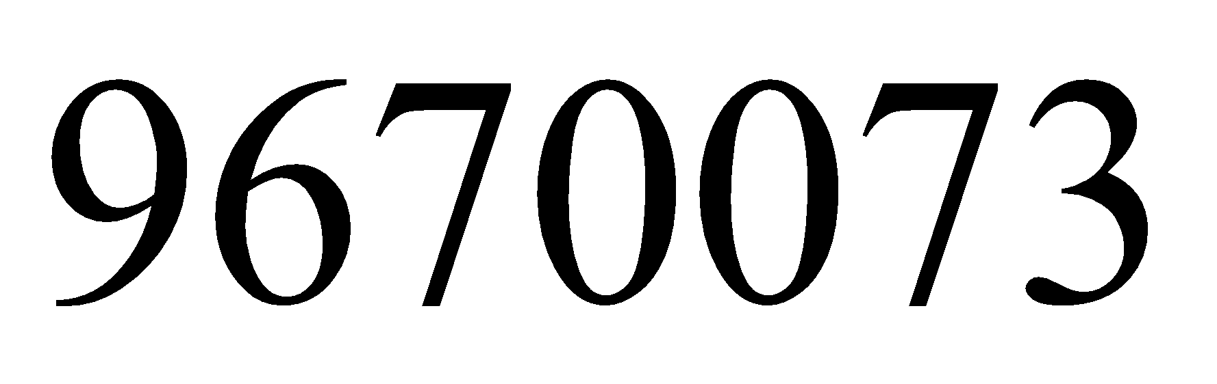
- (a) Given the numbers write down the sum of all numbers
which are divisible by 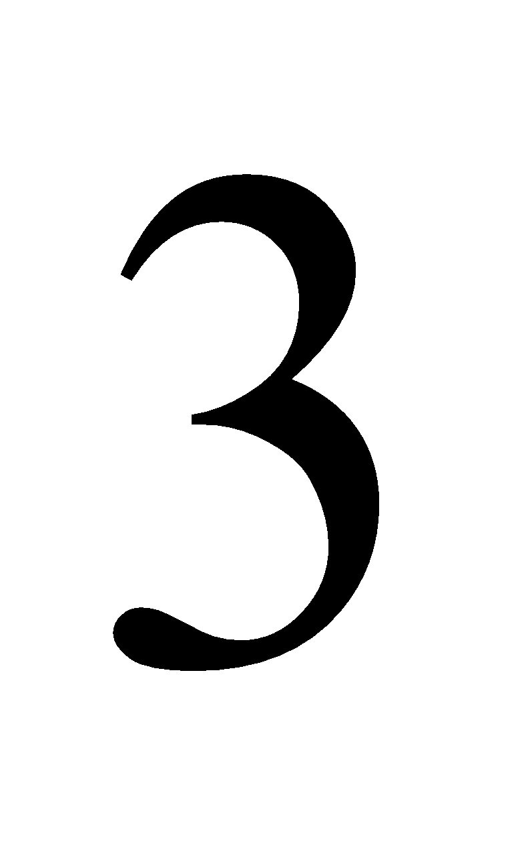
  - Write 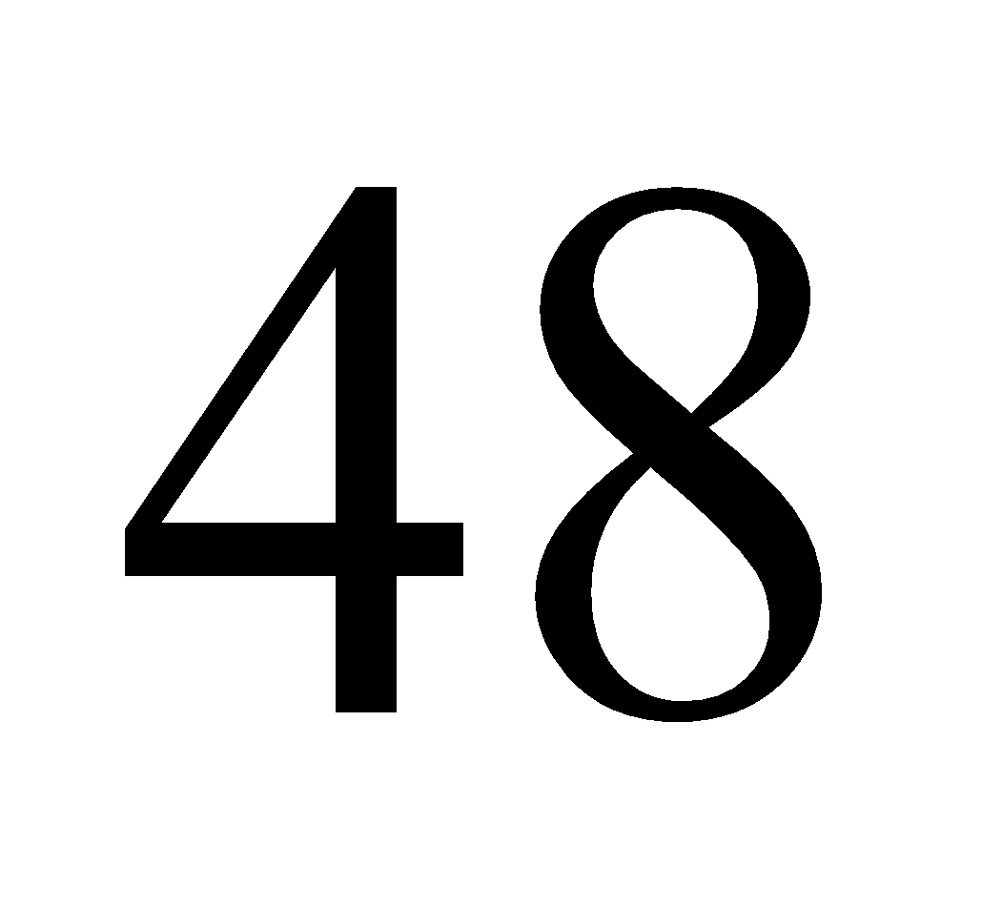 as the product of its prime factorization.
- (a) Find the LCM and GCF of 240,140 and 120
  - Write down all multiples of 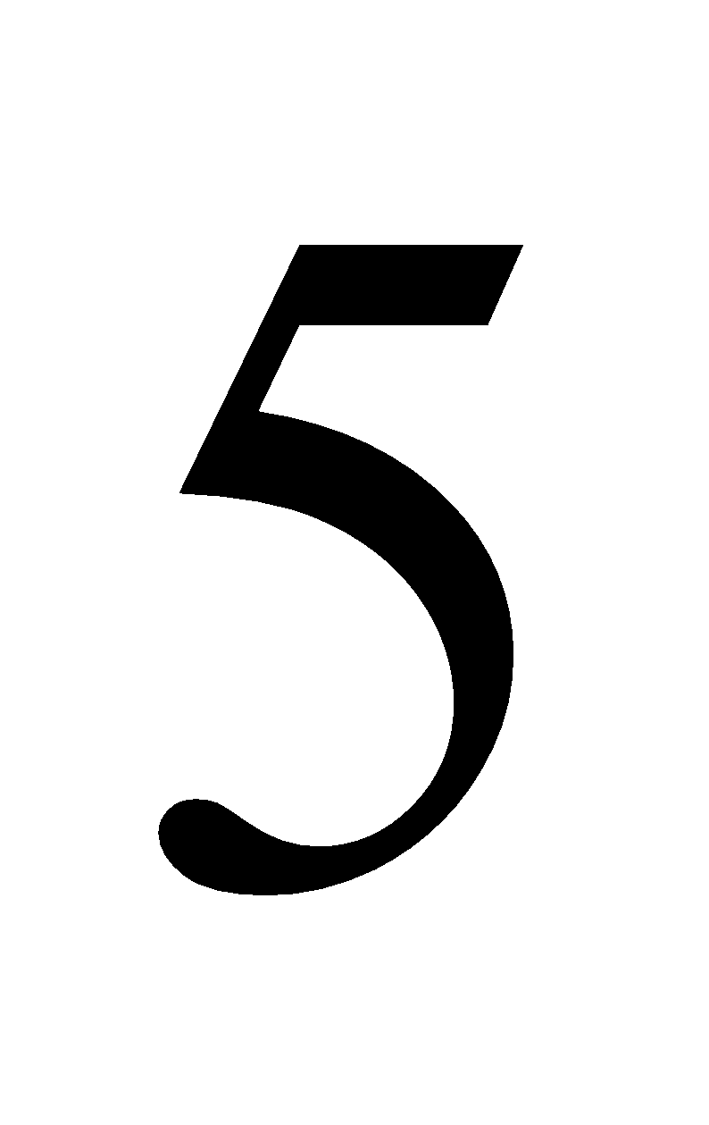 and 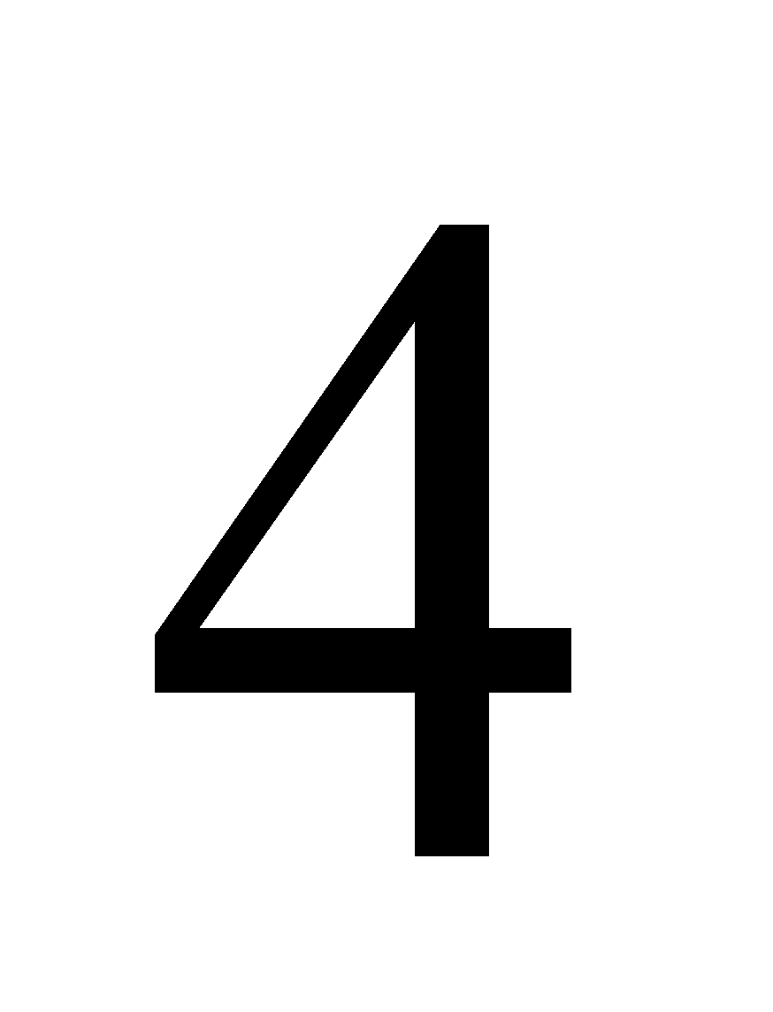 less than 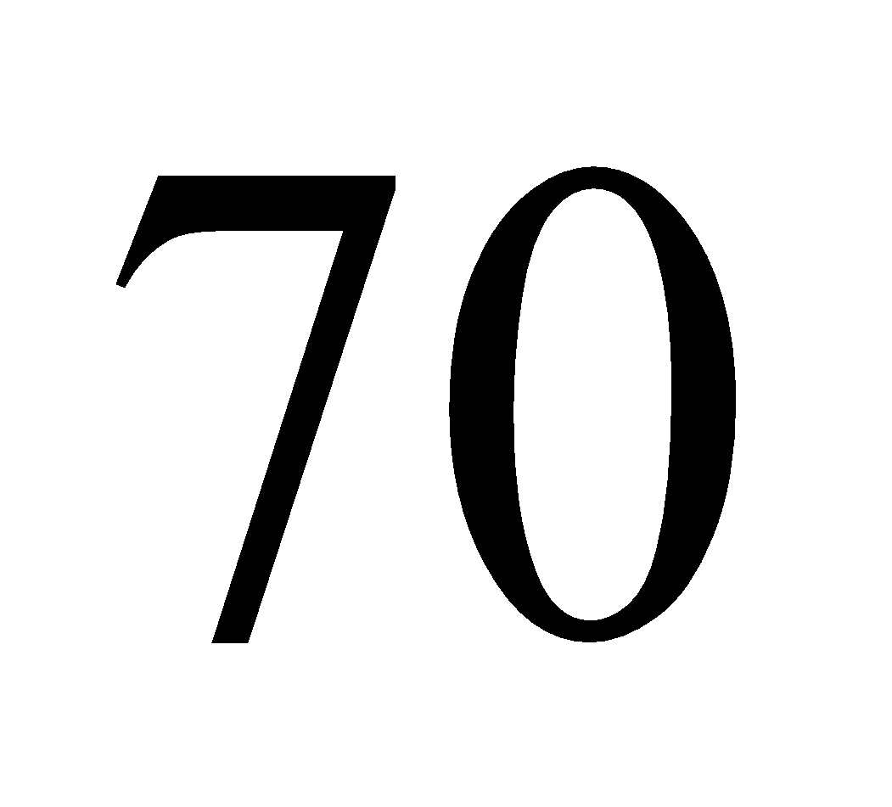then circle the common one.
- (a) From the numbers
.list
      - All prime numbers
      - All even numbers
      - All odd numbers
  - What number is both even and prime?
- Find the value of the following
(a) 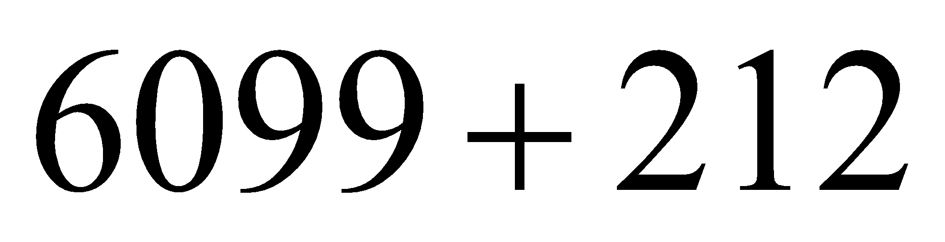
  - 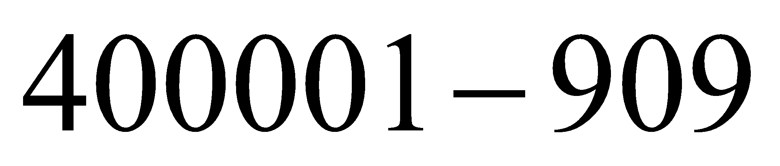(c) 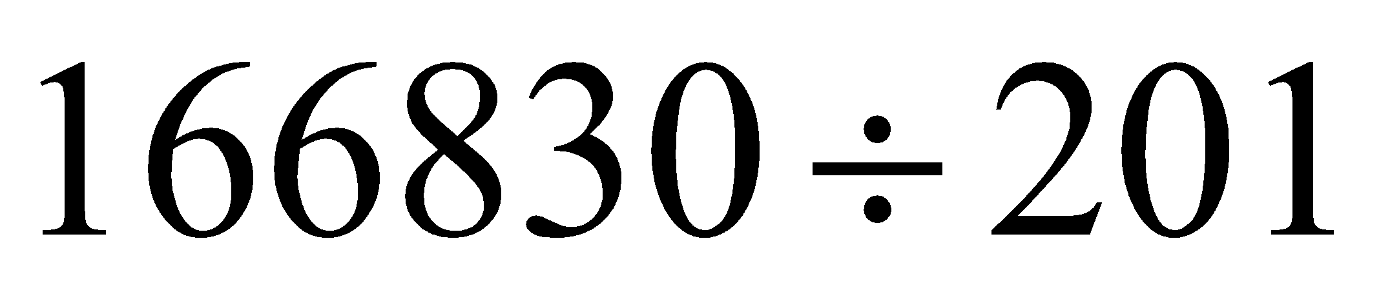
- (a) List all integers between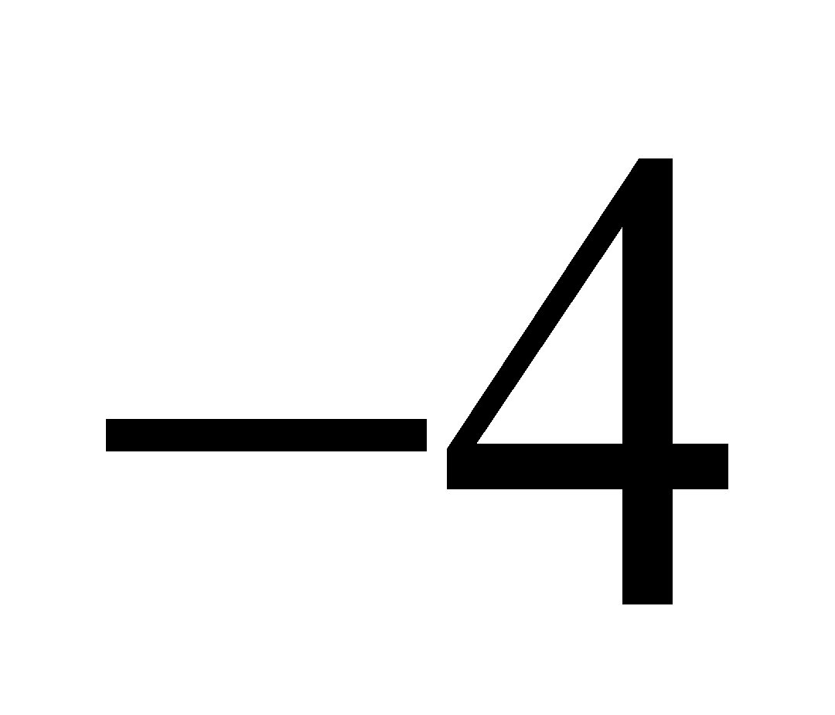 then present them on a number line.
and
  - By using number line find the solution of
(i) 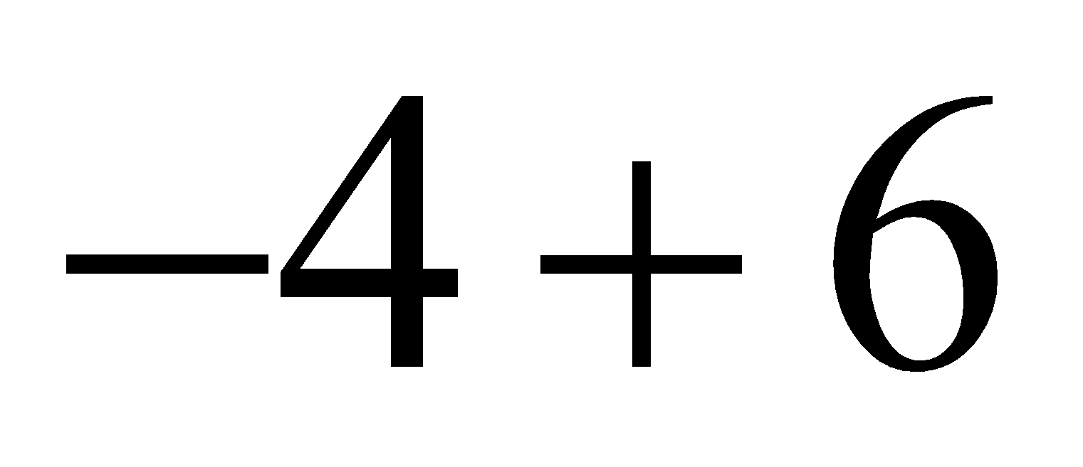 (ii) 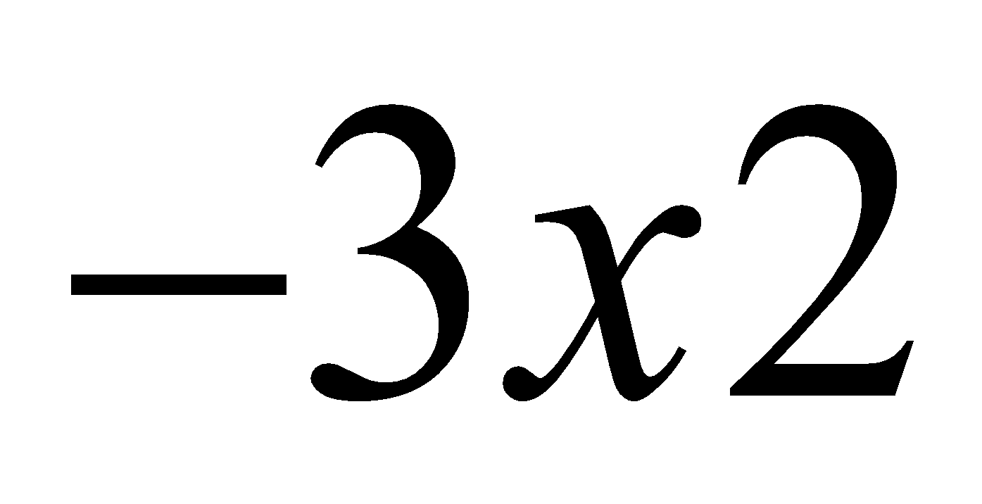
- (a) What is mathematics
  - Outline four importance of studying mathematics.
- (a) By using the rule of BODMAS evaluate 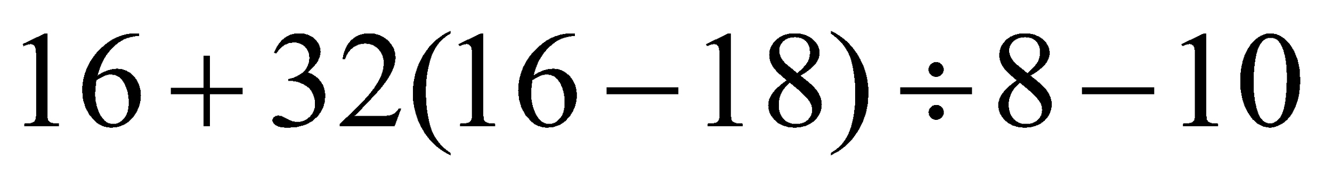
  - Find (i) 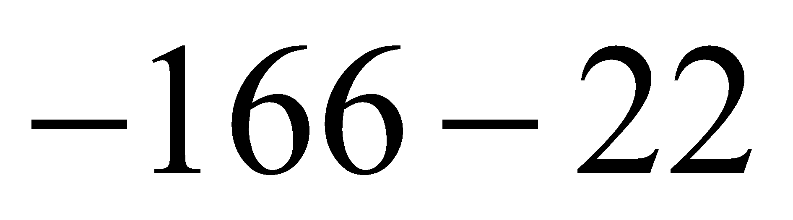
(ii) 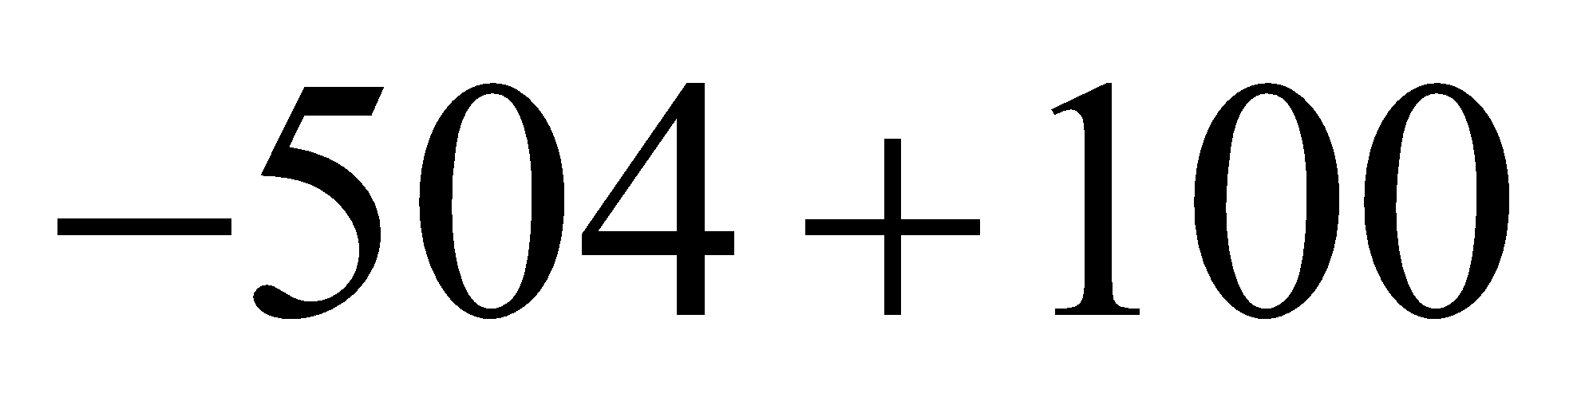
10.Richard sold 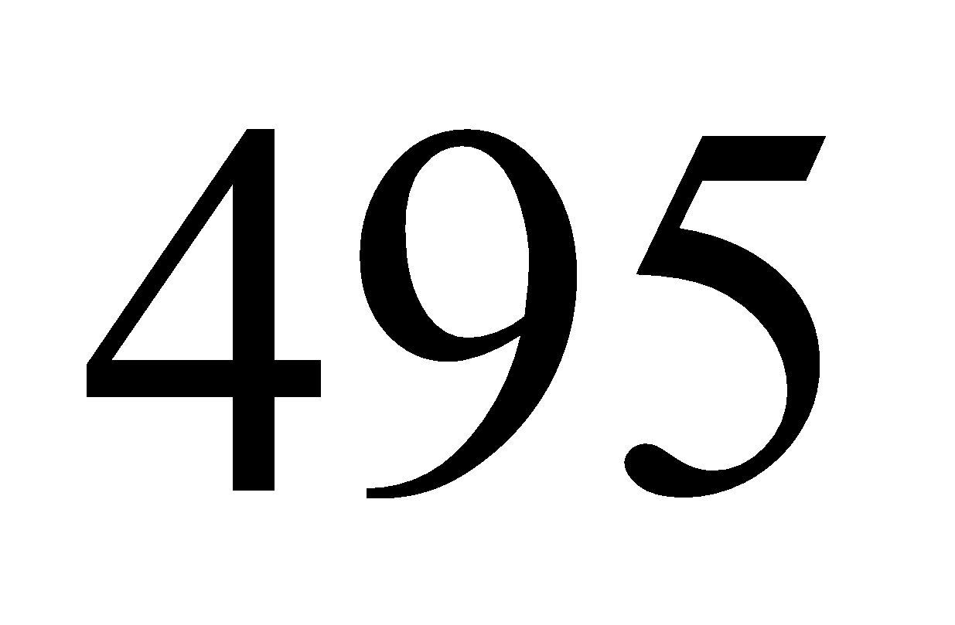 copies of the Guardian newspaper for 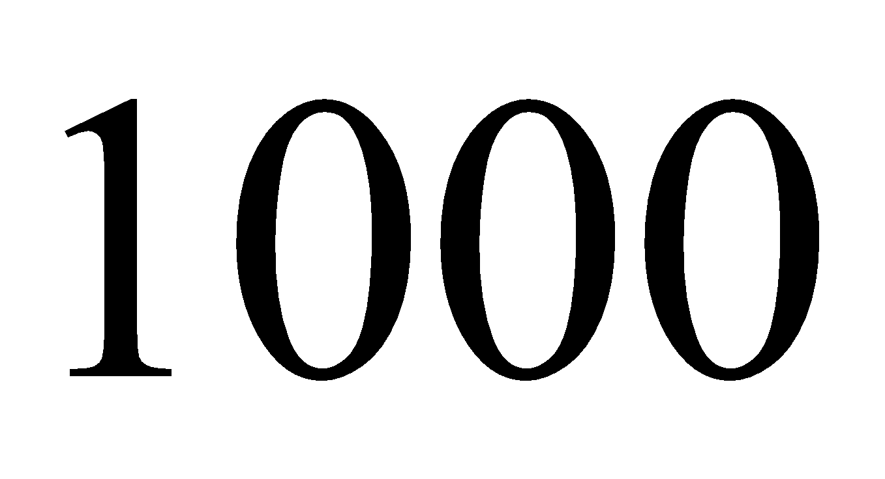shilling, 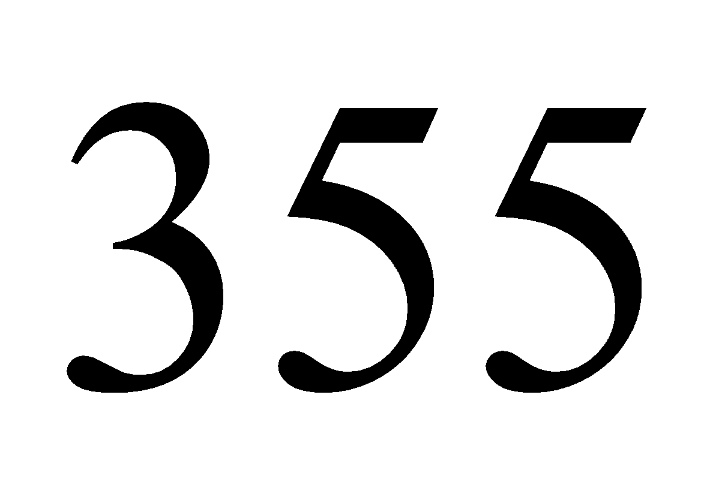 copies of
Uhuru newspaper for shilling each, and 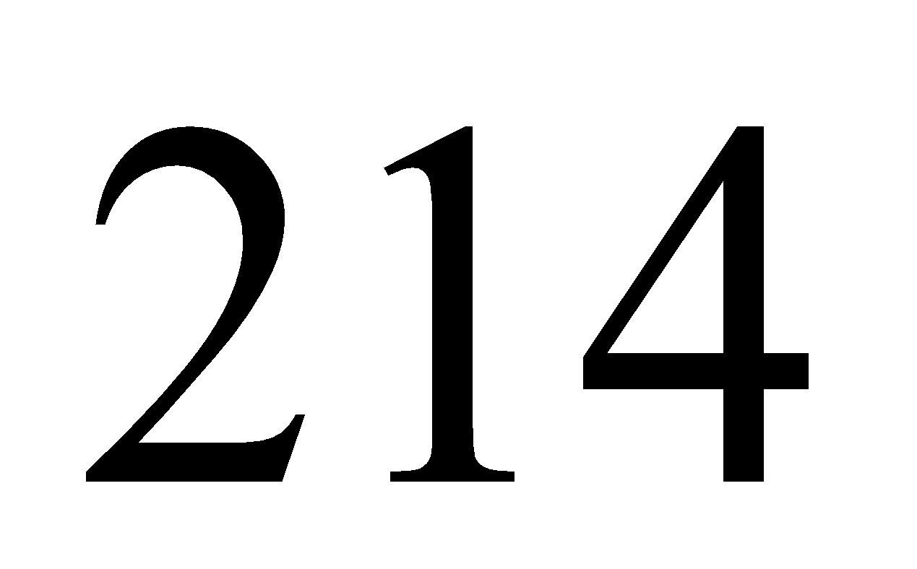copies of champion magazine for 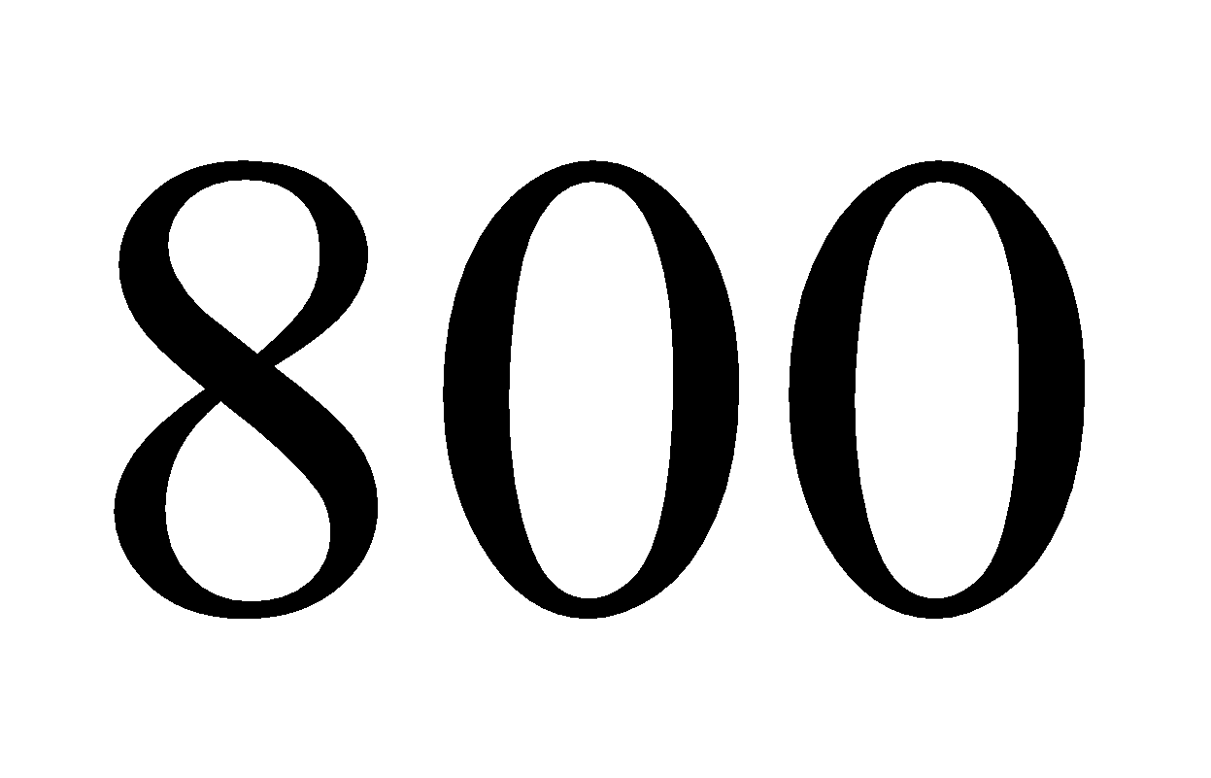shilling each. How much money did he collect?

