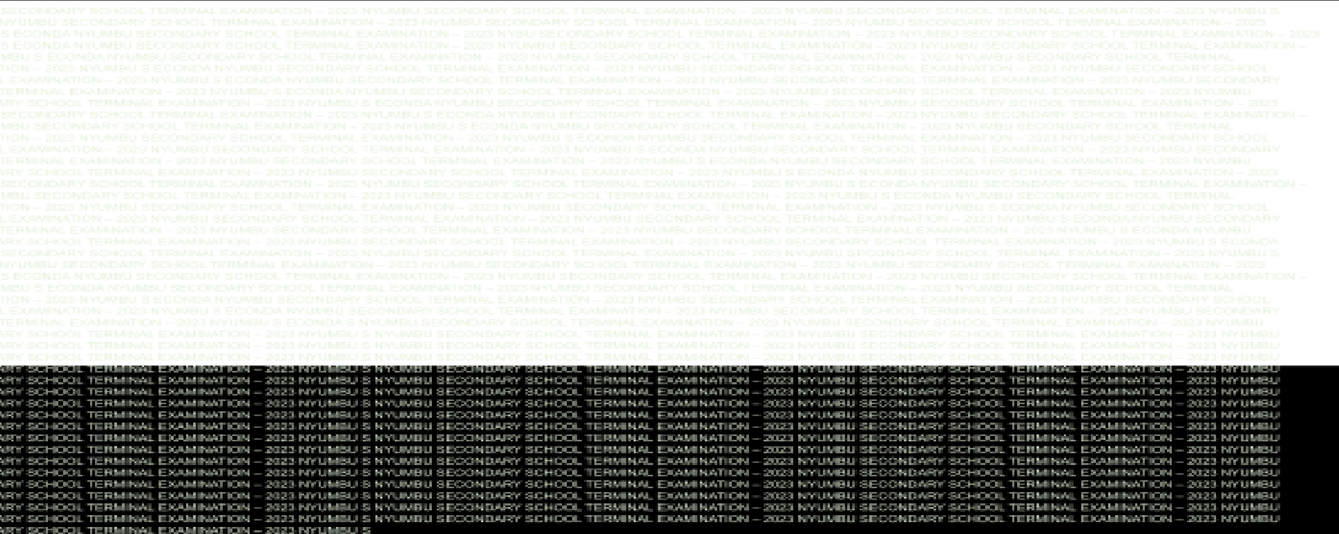
REGIONAL
ADMINISTRATION
AND
LOCAL
GOVERNMENT
KIBAHA
TOWN
COUNCIL
NYUMBU
SECONDARY
SCHOOL
FORM
ONE
MIDTERM
EXAMINATION
CODE:
013
GEOGRAPHY
TIME:
2:00
HOURS
YEAR:
2024

Instructions
- This paper consists of section A, B and C with a total of ten (10) questions.
- Answer all questions.
- Section A carries fifteen (15) marks, section B carries seventy (70) marks and section C carries fifteen (15) marks.
- All writing must be in black or blue ink.
- Answers must be written in the space provided.
- Cellular phones, calculators and any unauthorized materials are not allowed in the examination room.
- Write your Examination Number at the top right corner of every page.
FOR EXAMINER’S USE ONLY
QUESTIONS NUMBERS | SCORE | EXAMINER’S INITIAL
1
2
3
4
5
6
7
8
9
10
TOTAL
CHECKER’S INITIAL

SECTION A (15 Marks)
Answer all questions in this
1. For each of the items (i) – (x) choose the correct answer from the given alternatives and write it.
- The celestial body orbiting planets is:
A.The moon
B.The Earth
C.The sun
D.Solar system
- The arrangement of planets in space in relation to the position of the sun is:
I
  - Solar energy B. Solar panel C. The moon
D. Solar system
iii)The solar system has multiple bodies, the central body being
  - Earth
  - Moon
  - Sun
  - Planet
- The solar system is made up of the sun,planets and other heavenly bodies, Which planet has the shortest orbit?
  - Pluto
  - Mercury
  - Mars
  - Earth
- Which of the following planets is close to the sun?
A.Earth C.Jupiter
B.Mars D.Mercury
C.Physical geography
- Geography is the study of the D.Environmental geography interrelationship between....
  - Man and Environment B.Human and Economic geography
- The main branch of geography which also deals with the distribution of plant and animals
  - Practical geography C. Physical geography
  - Human and economic geography D. Environmental geography
Vii)John always see object with leading heads and bright tails moving in the sky at night.What is the name of object John sees everyday?
- Neptune  - Comets | - Meteors  - Asteroid
- The planet not colliding with one another as they revolve around the sun due to:
  - Sun energy
  - Sun's gravitational force
  - Sun hotest
  - Sun it's force
- Which of the following is true about the uses of solar energy?
A: Solar energy is used for water and home heating
B: Solar energy is used for drying clothes and watering
C: Solar energy is used in reducing rain
D: Solar energy is used to generate electricity
X) The spinning of a body on its axis is called:-
- Revolution
- Earth's movement
- Rotation
- Earth's curvature
i | ii | iii | iv | v | vi | vii | viii | ix | x
2. Match the items in List A with the most correct responses in List B by writing the letters of the responses beside the item number.
LIST A |  |  |  |  | LIST B
- The word solar comes from a Greek word " Sol"which means.  - The natural satellite of the Earth .  iii)The continent which not inhabitated by people .  iV) Elliptical path through which the heavenly bodies revolve around the sun. V).The planet which Support life. |  |  |  |  | - Orbit  - Antarctica  - Path  - South America  - Sun  - Mars  - Continent  - Earth  - Moon  - Africans  - The planet
 | LIST A | i | ii | iii |  | iv | v
 | LIST B

SECTION B (70 Marks)
Answer all questions in this section
- List five components of the solar system?
i) ……………………………………………………………………………………… ii) ……………………………………………………………………………………… iii)………………………………………………………………
iv) …………………………………………………………………………………… v) ……………………………………………………………………………………
- List five human activities that require geographical knowledge and skills
i)............................,(ii)......................,(iii)....................(iv)..................(v)......................
5.Why government encourage people to use solar energy rather than other energy sources in cooking nowdays? (give out five point)
i..........….........................................................................................
ii......................................................................................... iii....................................... ................................................. iv.......,............................................................................................
v...........,......................................................................................
6.Outline four contribution of solar energy to the emancipation of women in Tanzania. ……………………………………………………………………..………………………
……………………………………………..………………………………………………
……………………..………………………………………………………………………
………………………………………………………………………………………………
……………………………………………………………..………………………………
……………………..………………………………………………………………………
………………………………………………………………………………………………
……………………………………………………………..……………………………… ……………………………………………………………..………………………………
7.Give out Five uses of solar energy
i) ……………………………………………………………………. ii) ……………………………………………………………………… iii)……………………………………………………………. …… iv) …………………………………………………………………
v) …………………………………………………………….
8a)What do you understand the term orbit as applied in the solar system?
......................................................................................................................
........................................................................................................................
8b).Mention the planets which found in solar system in arrangement from the sun.
i)..............,ii).............,iii)..............,iv)............,(v)...........,(vi)............... (vii)................,(viii)..............
9)As form one students studying geography, educate your parents why is it important to study geography subject
i)………………………………………………………………………………………… ……………………………………………ii)………………………………………… …………………………………………………………………………………………ii ii)………………………………………………………………………………………
……………………………………………iv)…………………………………………
……………………………
v.).......................................................

SECTION C (15 Marks)
Answer questions ten (10) in this section
10.Differentiate between the following terms as used in geography
- Physical geography and Human and economic geography
…………………………………………………………………………………………
…………………………………………………………………………………………
…………………………………………………………………………………………
…………………………………………………………………………………………
…………………………………………………………………………………………
- Moon and Earth
…………………………………………………………………………………………
…………………………………………………………………………………………
…………………………………………………………………………………………
…………………………………………………………………………………………
…………………………………………………………………………………………
- Sun and solar energy
…………………………………………………………………………………………
…………………………………………………………………………………………
…………………………………………………………………………………………
…………………………………………………………………………………………
……………………………………………………………………………………
- Solar system and planets
…………………………………………………………………………………………
…………………………………………………………………………………………
…………………………………………………………………………………………
………………………………………………………………………………………… …………………………………………………………………………………………
V.Comets and meteors …………………………………………………………………………………………
…………………………………………………………………………………………
…………………………………………………………………………………………
…………………………………………………………………………………………
…………………………………………………………………………………………
…………………………………………………………………………………………
……………………………………………

