 (For Both School and Private Candidates)

PRESIDENT’S

OFFICE

REGIONAL

ADMINISTRATION

AND

LOCAL

GOVERNMENT

SONGEA DISTRICT COUNCIL

FORM

FOUR MOCK EXAMINATION

013

GEOGRAPHY

Time: 3 Hours March, 2025
1. This paper consists of section A, B and C.

Instructions

- Answer all questions in A and B and two (2) questions from section C.
- Map extract of ARUSHA sheet 55/3 is provided.
- Hand writing must be in black or blue ink and all diagrams should be done by a pencil.

SECTION A (16 Marks)
Answer all questions in this section

1. For each of the items (i) – (x) choose the correct answer from among the given alternatives and write its letter beside the item number in the answer sheet provided.

- In 1930 an object from space fell in Mbozi Mbeya, Tanzania. This object is now used as a tourist attraction for both domestic and foreign tourists. As a geographer, how do you call that object?
  - Meteorite
  - Comet
  - Asteroid
  - Meteoroid
  - Satellite

- What temperature will be experienced by the Posta ferry Dar es Salaam residents 0 metres above sea level if the temperature of Korogwe Tanga 1500 metres above the sea level is 23⁰C? A. 09⁰C B. 17⁰C
C. 32⁰C D. 14⁰C

of

E. 12⁰C

- My brother is living in the area where houses are far from one another and agriculture is the main activity in the area. What kind of settlement pattern is depicted in the area?
  - Liner settlement
  - Sparse settlement
  - Urban settlement
  - Nuclear settlement
  - Mega settlement

- The owner of a plastic industry ordered the management to use environmental friendly energy sources in production. Which energy source could be used in that industry?
  - Petroleum
  - Nuclear
  - Fuel wood
  - Coal
  - Solar

- Form one students were watching a Television program on various human activities in Kidole village. Which among the observed activities is of environmental conservation method in that village?
  - Spraying
  - Deforestation
  - Afforestation
  - Migrating
  - Burning

- Kashasha jogging club from Migombani in Dar es Salaam went to Moshi region to climb Mount Kilimanjaro. If you classify that mountain, it will fall under which category of the following mountains?
  - Residual
  - Volcanic
  - Fold
  - Block
  - Rock mountain
- In Shinyanga, most farmers leave idle the exhausted part of the land for a certain period to regain fertility and then cultivate them again. How can you call this farming technique?
  - Shifting cultivation
  - Sedentary farming
  - Bush fallowing
  - Aquaculture
  - Mixed farming viii. Most of the areas in Pwani region are frequently experiencing flood during heavy
rain.
Which among the following soil properties accelerate the occurrence of such calamity? A. Soil Ph
  - Soil porosity
  - Soil shape
  - Soil air
  - Soil temperature

- Bahati went to enjoy the sea breeze at Coco beach in the Indian Ocean during the weekend. She saw a big forest over the area while passing along it. How does that forest differ from other forest types regarding their growing condition in certain areas? A. Heavy rain B. Deep soil
  - Saltwater
  - Cold climate
  - Mountainous climate

- Jaha completed his form four education in 2021. He lives in the region characterized by little rainfall, high temperature during the day, very cold during night and common vegetations are thorn trees and cactus. Currently he is working in dates farm in his region. In which climatic region does Jaha live?
  - Mediterranean
  - Equatorial
  - Monsoon
  - Savannah
  - Hot desert

2. Match the descriptions of the types of folds in List A with the type of folds in List B by writing the letter of the correct answer beside the item number in the answer sheet provided.

List A | List B
- Sunrise and sunset  - Circumnavigation of the earth  - Aerial photograph of the earth  - Ship’s visibility  - Lunar eclipse  - The earth’s curved  horizon | - The earth appears to have a curved horizon when viewed from a high cliff.  - The visibility of an arriving ship which is far away starts with the flag, then the mast and eventually the whole ship.  - When light from the sun is obstructed, a circular shadow is observable.  - A photograph taken by airplane from the air show that the earth is curved.  - People in the east see the sun earlier than those in the west.  - If you travel from a certain point on the earth by going straight around the earth, you will eventually come back to the point of origin.

SECTION B (54 Marks)
Answer all questions in the section

- Study the map extract of Arusha sheet 55/3 and then answer the following questions
  - Describe the relief of the area
  - Describe the settlement patterns of the area shown in the map
  - Change the given scale on the map into the statement scale.
  - Identify three (3) economic activities on the map.

- Alex Morison, a form four student at Mtakuja secondary school was presenting on the class the construction of divided bar graph; during her presentation he mixed the procedures of presenting the data. As a form four students assist him by;
    - Outline steps for constructing the graph.
    - Point out three merits and three demerits of the method.
    - Present the statistical data of cash crop production (000tones) in Tanzania in the year 2005 to 2008 by using divided bar graph.
ear/Crop | 05 | 06 | 07 | 08
 | 0 | 0 | 0 | 0
 | 0 | 0 | 0 | 0
ubber | 0 | 0 | 0 | 0
offee sal
- Carefully study the following photograph and answer the questions that follow:
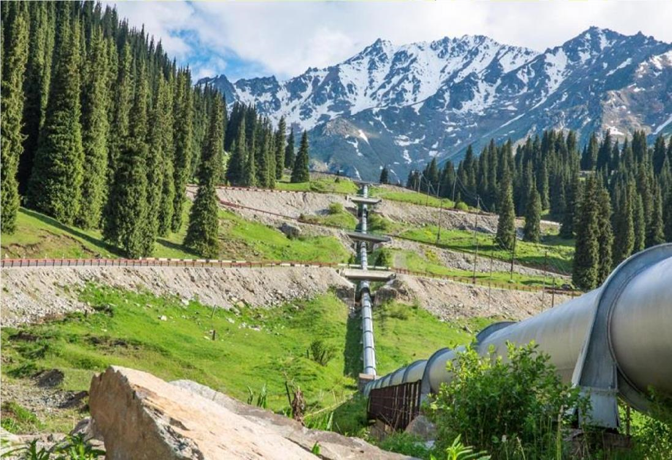

  - Identify mode of transport used in the area.
  - Name two products and examples of the mode of transport that you have mentioned found in your country.
  - At what time the photograph was taken?
  - Suggest the possible processes responsible for the formation of the relief feature seen on the background
  - Apart from transportation, suggest the possible three economic activities that might take place in the area

- The form three surveying team of Mango secondary school was told by their geography teacher

to conduct chain survey around their sport ground so as to make boundaries of their sport ground. In accomplishing their survey, the team realized that they have collected data with discrepancies due to improper arrangement of the poles.
      - Name and explain the type of discrepancy the surveying team encountered?
      - What are the four (4) things the surveying team was supposed to consider so as to avoid such discrepancy?
      - Identify three people who are involved in the form three surveying team at Mango secondary school.

- During holiday, Mazembe visited his sister who is living at Congo basin in central Africa located between 0⁰ to 5⁰ latitudes south of the equator. This area receives heavy rainfall throughout the year.

      - Identify type of climatic region in which Mazembe’s sister lives.
      - Mention two (2) areas experiencing that type of climate in (a) above apart from Congo Basin.
      - In four (4) points describe common human activities carried out in that climatic region.

- Suppose you want to conduct a research about maize production in your district from 2015 to 2020 and your interest is to know whether the production was increasing or decreasing. Your plans is to consult the farmers who were directly involved in the Maize production for the said period and the District Agricultural Extension officer for more information.
        - What will be the best research approach for your study? Give reason.
        - Describe the main source of data for your study
        - Identify two individuals who will be the respondents for your study.
        - Formulate the null hypothesis and Alternative hypothesis for your study.
        - As a good researcher, why do you think it is very important to pass through various publications like journals, books, research reports done by other people, Newspaper, before you conduct your study? Give four (4) points.

SECTION C (30 Marks)
Answer two (02) questions in this section

- In the one of the world economic forums President Samia Suluhu Hassan said that “One among the factors for wide gap between Africa and Europe is level of manufacturing industries in such a way we can’t compete with their industrial goods in the world market.” Suggest six ways that can be employed by government to uplift this sector.

- With examples explain six (6) economic advantages of soil.

- Despite the challenges the mining sector faces, it has advantages to our economy. With six (6) points support the statement.

of

