
CHRISTIAN SOCIAL SERVICES COMMISSION (CSSC)
CSSC JOINT EXAMINATIONS FOR CHURCH SCHOOLS
EASTERN ZONE
FORM II PRE – NATIONAL EXAMINATION 2024
INFORMATION AND COMPUTER STUDIES (ICS)
CODE: 036
Time: 2:30 Hours Date: Wednesday, 28th August, 2024 p.m
___________________________________________________________________________

Instructions
1. This paper consists section A, B and C with a total of ten (10) questions.
2. Answer all questions in both sections.
3. Section A and C carry fifteen (15) marks each and section B carry seventy (70) marks.
4. Write your answer in the space provided
5. All communication devices are not allowed in the examination room.
6. Cellular phones and any unauthorized materials are not allowed in the Examination room.
7. Write your Examination Number on the top right hand corner of every page.

FOR EXAMINER’S USE ONLY
QUESTION NUMBER | SCORE | EXAMINER’S INITIALS
1
2
3
4
5
6
7
8
9
10
TOTAL
CHECKER’S INITIALS

SECTION A (15 Marks)
Answer all question from this section
- For each of the following items (i – x), choose the letter of the most correct answer and write its letter in the box provided.
- A secretary was typing a letter, after finishing she was asked to make some changes to some of the texts of that letter, these changes included changing font, font size as well as color. These task are general termed as
A. Decorating
B. Clear formatting
C. Printing
D. Formating

- Many are the output devices which are used to transfer machine readable data format into human readable format, which list among the following contains only input devices?
A. Monitor, speaker, projector and printer.
B. Keyboard, mouse, scanner, microphone.
C. Monitor, printer, mouse, keyboard and speaker.
D. Stylus, barcode reader, monitor and printer.

- Head master of Mirambo secondary school wanted to have a network at his school for easy files transfer between school office buildings located at the same school, which network is suitable among the following
A. WWW
B. PAN
C. WAN
D. LAN

- In a spread sheet, where a column and a row intersect so as to make a box like shape is called cell. When this cell is selected its address is visible in
A. formula bar
B. Namebox
C. Sheet tab
D. Clip board

- What is the smallest and largest font size tool on formatting toolbar?
A. 8 and 72
B. 8 and 68
C. 6 and 72
D. 6 and 76

- Why Charles Babbage is considered to be a father of computer?
- He was a founder of Napier’s bones
- He discovered ENIAC
- He created punching Card
- He was a founder of analytical engine.
- My friend said that he saw at CRDB bank as the bank teller was printing pay in slip. The printer was making noise and the letters on the bank slip were as if obtained as the results of hammering mechanism. Due to this information it is possible that a printer used was in the category of
A. laser printer
B. Non-impact printer
C. Impact printers
D. Plotter

- In a computer system unprocessed number, text and pictures for various purpose are known as
- Content
- B. Data
- Information
- Knowledge

- The prevention of data loss from power failure is done by ____
- Socket Extension
- Multi -plug socket
- Voltage Stabilizer
- UPS

- An operating system which allows more than one process to be operate at the same time is called
A. General purpose
B. Multi – user operating system
C. Single User – Operating system
D. Proprietary Operating system

- Match the following items between Column A and their proper responses in Column B.

Column A | Column B
- Central Processing Unit  - Arithmetic Logic Unit  - Control Unit  - Memory Unit  - Cache memory | - Perform All activities in the central processing Unit  - Deals with addition and Subtraction only  - It adds speed to central processing unit.  - Deals with addition, subtraction, less than, equal to.  - It contains two smaller unit elements of CPU during operation  - The one used to store information of the program.  - It is the heart or the brain of the computers system during execution  - Example hard disk or CD

Answers
Column A | i | ii | iii | iv | v | vi
Column B

SECTION B. (70 Marks)
Answer all questions

- (a) Give the long form of the following acronyms as used in ICS (5 Marks)
- PDF………………………………………………………………………………………...
- MOBO……………………………………………………………………………………..
- VDU ………………………………………………………………………………………
- Wi-fi ………………………………………………………………………………………
- UPS ………………………………………………………………………………………..

- Write the shortcut keys used to execute the following commands in MS. word Processor.
(5 Marks)
- Paste a document …………………………………………………………………………...
- Close a document …………………………………………………………………………..
- Cut a document ……………………………………………………………………………
- Print a document …………………………………………………………………………...
- Save a document …………………………………………………………………………

- (a) Why information is important to Tanzanian society as refered in ICS?
Give five points. (5 marks)
- ……………………………………………………………………………………………………………………………………………………………………………………………….
- ……………………………………………………………………………………………………………………………………………………………………………………………….
- ……………………………………………………………………………………………………………………………………………………………………………………………….
- ……………………………………………………………………………………………………………………………………………………………………………………………….
- ……………………………………………………………………………………………………………………………………………………………………………………………….

- Tradition ways of information dissemination have its unique characteristics. State any five among them. (5 marks)
- ……………………………………………………………………………………………………………………………………………………………………………………………….
- ……………………………………………………………………………………………………………………………………………………………………………………………….
- ……………………………………………………………………………………………………………………………………………………………………………………………….
- ……………………………………………………………………………………………………………………………………………………………………………………………….
- ……………………………………………………………………………………………………………………………………………………………………………………………….

- (a) Mr. Z wants to buy a new computer for his project, you as a computer specialist
advise him four criteria to consider when buy his new computer.
- ……………………………………………………………………………………………….
- ……………………………………………………………………………………………….
- ……………………………………………………………………………………………….
- ……………………………………………………………………………………………….

- What do you think is the first software to be installed in his new computer?
…………………………………………………………………………………………………….

- Mention four function of the software installed in part (b) above.
  - ……………………………………………………………………………………………….
  - ……………………………………………………………………………………………….
  - ……………………………………………………………………………………………….
  - ……………………………………………………………………………………………….

- (a) Computer evolution relates with technology level that has been used. Briefly explain
the table which shows computer generation and the technology used. (5 Marks)

S/N | Computer generation | Technology used
1 |  | Integrated Circuit
2 | Fourth generation
3 |  | Vacuum Tube
4 | Second generation
5 | Fifth generation

- Highlight five achievements in the fifth generation computer (5 Marks)
  - ………………………………………………………………………………………
  - ………………………………………………………………………………………
  - ………………………………………………………………………………………
  - ………………………………………………………………………………………
  - ………………………………………………………………………………………..

- Read the following snapshot and answer the following question

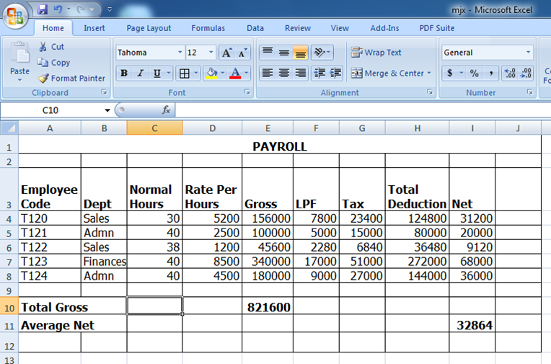

- Give the name of the program used to create the snapshot above...…………………………….
- Write the font face and font size used to type the details in given snapshot…………………….
- Give the reference name of the active cell……………………………………………………...
- What format was done for the cells in row 3? ……………………………………………….....
- Write the function required to calculate the total gross…………………………………………
- Write the function required to calculate the highest net pay……………………………………

- (a) Figure 1 shows a computer network topology. Use it to answer the questions that
follow.

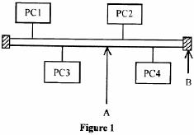

- Identify the name of topology in figure 1. …………………………………………………
- State the function of each of the parts labeled A and B.
A ……………………………………………………………………………………
B ……………………………………………………………………………………
- What are the two advantages and disadvantages of using a physical network structure above?
Advantages
……………………………………………………………………………………………………………………………………………………………………………………………….
Disadvantages
……………………………………………………………………………………………………………………………………………………………………………………………….

(b) Give the function of each of the following:
- Network interface card
……………………………………………………………………………………………….
- Router
……………………………………………………………………………………………….
- Switch
……………………………………………………………………………………………….

- (a) Kunta would like to send photos to Kinte via e-mail. Outline the steps Kunta
would follow to send the photos as file attachments. (5 Marks)
………………………………………………………………………………………………………………………………………………………………………………………………………………………………………………………………………………………………………………………………………………………………………………………………………………………………………………………………………………………………………………………………………………………………………………………………

(b) Outline five advantages of using e-mail. (5 Marks)
- ………………………………………………………………………………………………………………………………………………………………………………………….
- ………………………………………………………………………………………………………………………………………………………………………………………….
- ………………………………………………………………………………………………………………………………………………………………………………………….
- ………………………………………………………………………………………………………………………………………………………………………………………….
- ………………………………………………………………………………………………………………………………………………………………………………………….

SECTION C: (15 Marks)

- Write an essay showing three (3) points on how computer network can be important to the society and also three (3) points showing how it can be harmful to the society.
……………………………………………………………………………………………………………………………………………………………………………………………………………………………………………………………………………………………………………………………………………………………………………………………..………………………………………………………………………………………………………………………………………………………………………………………………………………………………………………………………………………………………………………………………………………………………………………………………………………………………………………………………………………………………………………………………………………………………………………………………………………………………………………………………………………………………………………………………………………………………………………………………………………………………………………………………………………………………………………………………………………………………………………………………………………………………………………………………………………………………………………………………………………………………………………………………………………………………………………………………………………………………………………………………………………………………………………………………………………………………………………………………………………………………………………………………………………………………………………………………………………………………………………………………………………………………………………………………………………………………………………………………………………………………………………………………………………………………………………………………………………………………………………………………………………………………………………………………………………………………………………………………………………………………………………………………………………………………………………………………………………………………………………………………………………………………………………………………………………………………………………………………………………………………………………………………………………………………………………………………………………………………………………………………………………………………………………………………………………………………………………………………………………………………………………………………………………………………………………………………………………………………………………………………………………………………………………………………………………………………………………………………………………………………………………………………………………………………………………………………………………………………………………………………………………………………………………………………………………………………………………………………………………………………………………………………………………………………………………………………………………………………………………………………………………………………………………………………………………………………………………………………………………………………………………………………………………………………………………………………………………………………………………………………………………………………………………………………………………………………………………………………………………………………………………………………………………………………………………………………………………………………………………………………………………………………………………………………………………………………………………………………………………………………………………………………………………………………………………………………………………………………………………………………………………………………………………………………………………………………………………………………

