THE PRESIDENT’S OFFICE
REGIONAL ADMINISTRATION AND LOCAL GOVERNMENT

BUNDA DISTRICT COUNCIL

FORM TWO PRE-NATIONAL EXAMINATION

041 BASIC MATHEMATICS
MARKING SCHEME SEPTEMBER 2023

2 | 30 | 50
3 | 15 | 25
5 | 5 | 25
5 | 1 | 5
 | 1 | 1……..01 mark
LCM= 2 × 3 × 5 × 5
= 150 minutes………………………...……..01 mark

150 minutes = 2 hours 30 minutes……….01 mark

1.

(
a) Find the LCM of 30 and 50
Next reporting = 11 ∶ 45 + 2: 30 = 2: 30 𝑝. 𝑚………………………………………….01 mark
Therefore they will next report together at 2:30 p.m………………………….……..01 mark

(b) Female committee members’ fraction = 1 −
= − ……………………………………...01 mark
= …………………………………….……..01 mark
Female committee members = × 60 …………………………………………………...01 mark
= 20 members…………………………………………...02 mark

- (a) (i) 8.129 ÷2= 4.0645 ……………………………………………………………………………..01 mark
8.129 ÷ 2 ≈ 4.064 ( 4 significant figures)…………………………………………..01 mark

(ii) 8.125≈ 8.13( hundredths)………………………………………………………….…01 mark

(b) (i) 1𝑡 = 1 000𝑘𝑔……………………………………………………………………………….00 mark
𝑦 = 6 000 𝑘𝑔 1𝑡 × 6 000 𝑘𝑔
𝑦 = ……………………………………………………………………...00 mark
1 000 𝑘𝑔
𝑦 = 6𝑡………………………………………………………………………………………….……01 mark
1 trip= 6𝑡…………………………………………………………………………………………..00 mark
𝑥 = 30 𝑡
1 𝑡𝑟𝑖𝑝 ×30 𝑡
𝑥 = ……………………………………………………………………………00 mark
6𝑡 = 5𝑡
Therefore the pick up will make 5 trips……………………………………………………01 mark

(ii) 2030 hours−12 00 ℎ𝑜𝑢𝑟𝑠 = 8: 30 𝑝. 𝑚 ……………………………………………..01 mark
8: 30 𝑝. 𝑚 + 6 ℎ𝑜𝑢𝑟𝑠 = 2: 30 𝑎. 𝑚

Therefore the time was 2:30 a.m after 6 hours of flight………………………..01 mark
- (a) Find the height of the trapezium

𝑎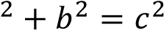
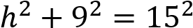
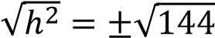
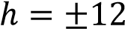



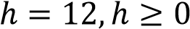……………………………………………………………………………..….…01 mark
h

9

c
15

c
Area of trapezium (A)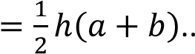
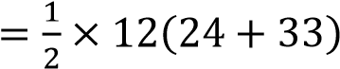
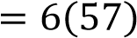
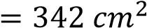………………………………………………………..……01 mark Area of circle O (A)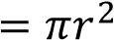
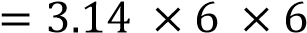
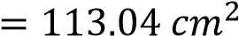………………………………………………………………………..01 mark
The area of the shaded region
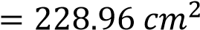
Therefore the area of the shaded region is 228.96 𝑐𝑚………………………….….01 mark
(b) 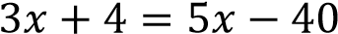(Alternate interior angles𝐷𝐸 )……………………….……01 mark
∥
𝐴𝐵
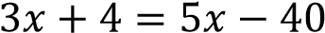
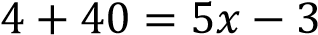𝑥………………………………………………………………………………..…...01 mark
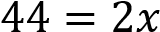
𝑥
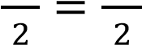
𝑥 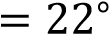……………………………………………………………………………………………..…01 mark
𝐶𝐷𝐸 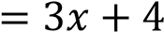
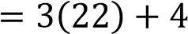
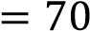°……………………………………………………………………………………………...…01 mark
𝐶𝐷𝐹 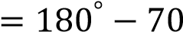°
°……………………………………………………………………………………….….…...01 mark

- (a) Let the numbers be 𝑥 𝑎𝑛𝑑 𝑦
𝑥 + 𝑦 = 24…………………………………………………………………………...….01 mark
−3𝑥 + 2𝑦 = 8…………………………………………………………………………….…..01 mark
Solve equation 1 and 2 by elimination method
2 |−𝑥3+𝑥+𝑦=2𝑦24=8
2𝑥+2𝑦=48
−3𝑥+2𝑦=8
− |₋^{2𝑥}₃⁺_{𝑥+}^{2𝑦}_{2𝑦}⁼₌⁴⁸₈……………………………………………………………………………..…….01 mark
5𝑥 = 40
5𝑥 40
=
5 5
𝑥 = 8………………………………………………………………………………….…….…01 mark
Substitute 8 for 𝑥 in equation 1
𝑥 + 𝑦 = 24
8 + 𝑦 = 24
8 − 8 + 𝑦 = 24 − 8
𝑦 = 16…………………………………………………………………………………….….01 mark
Therefore the numbers are 8 and 16 respectively
(b) 𝑥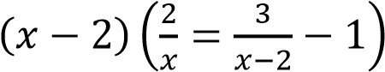
2(𝑥 − 2) = 3(𝑥) − 1(𝑥(𝑥 − 2)
2𝑥 − 4 = 3𝑥 − 𝑥² + 2𝑥
𝑥² − 3𝑥 = 4…………………………………………………………………………………01 mark
𝑥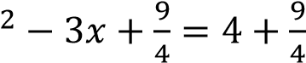
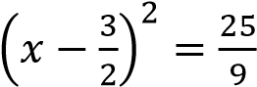……………………………………………………………………………01 mark
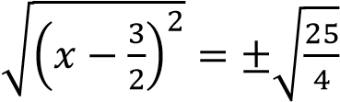
𝑥 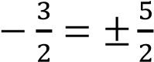 ………………………………………………………………….….….01 mark
𝑥 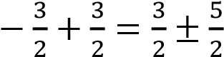
𝑥 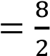 𝑜𝑟 𝑥 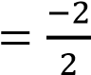
𝑥 = 4 𝑜𝑟 𝑥 = −1……………………………………………………………….…......02 marks

5. (a)Total parts= 1 + 3 + 4 = 8 𝑝𝑎𝑟𝑡𝑠…………………………………………...….01 mark
Difference in shares= (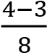) × 560 000 ………………………………….....01 mark
= × 560 000……………………………….………...01 mark
= 70 000 shillings
Therefore B got 70 000 shillings less than C…………………………..……..…02 marks
Alternatively
Total parts = 1 + 3 + 4 = 8 parts………………………………….………..……01 mark
B’s share= × 560 000
= 210 000 shillings ………………………………………………………….……01 mark
C’s share = × 560 000
= 280 000 shillings……………………………………………………..…..01 mark C’s share− B’s share = 280 000 − 210 00 …………………………………..01 mark
= 70 000 shillings
Therefore B got 70 000 shillings less than C ………………………………..….…01 mark

(b) 𝐴 = 𝑝 + 𝑝𝑡𝑟………………………………………………………………..…………………01 mark
= 4 000 000 + 4 000 00 × 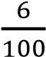 × 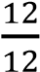 ………………………………..……………..…01 mark
= 4 000 000 + 240 000 ……………………………………………………..…………..…01 mark
= 4 240 000
Therefore the company will pay 4 240 000 shillings after one year……02 marks

- (a) Given point are (0 ,−3) and (4, 0) 𝑚 = 𝑦^{2−𝑦1}…………………………………………………………………………..…00 mark
𝑥2−𝑥1
𝑚 = 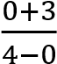 = ……………………………………………………………………..…….01 mark
𝑚 = , (0, −3),(𝑥, 𝑦)
      - 𝑦+3
= ………………………………………………………………………..………..01 mark
      - 𝑥
3𝑥 = 4𝑦 + 12 ………………………………………………………………………..00 mark
3𝑥 − 12 = 4𝑦
𝑦 = 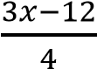
𝑦 = 𝑥 − 3 ……………………………………………………………………01 mark
(b)

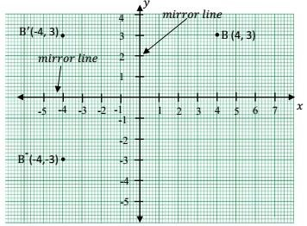
B (4, 3) → B′(-4, -3)

3𝑎−3𝑏 3𝑎−3𝑏
- (a) (i) = × ………………………………01 mark
√
𝑎
+
√
𝑏
√
𝑎
+
√
𝑏
√
𝑎
−
√
𝑏
√
𝑎
−
√
𝑏
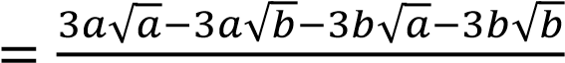
𝑎−𝑏
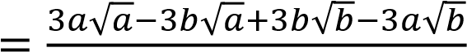
𝑎−𝑏
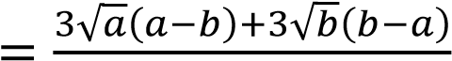
𝑎−𝑏
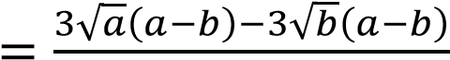…………………………...01 mark
𝑎−𝑏
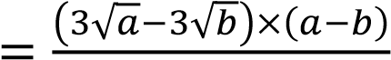
𝑎−𝑏
𝑏 ………………………………………………………...01 mark
=
3
√
𝑎
−
3
√

(ii) 2^{𝑥} = 3
2^{−3𝑥} = (2^{𝑥})⁻³ = 3⁻³……………………………………………..01 mark
= 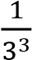 = 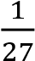 𝑜𝑟 27⁻¹………………………………………………….01 mark

……………………………………….…01 mark
log₂ 48 − log₂ 6 = 𝑦 − 3
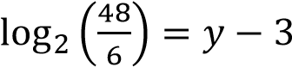 …………………………..…………………………01 mark
log₂ 8 = 𝑦 − 3 …………………………………………………….……01 mark log₂ 2³ = 𝑦 − 3
3 log₂ 2 = 𝑦 − 3…………………………………….…………………01 mark
3 = 𝑦 − 3
𝑦 = 6…………………………………………………………………01 mark

- (a) 𝐴𝐶 ≅ 𝐶𝐺 (Given side S)…………………………………………………………..….01 mark
𝐸𝐶 Is a common side S…………………………………………………..………….…01 mark

𝐸𝐴 ≅ 𝐸𝐺 (Bisected by 𝐸𝐶)…………………………………………………………..….01 mark
∆𝐺𝐸𝐶 ≅ ∆𝐴𝐸𝐶( SSS Theorem)………………………………………………….………01 mark

𝑋𝑌 𝑋𝐴 𝐴𝑌
(b) = = =Scale factor or ratio of proportionality
𝐵𝐶 𝐴𝐵 𝐴𝐶

𝐴𝑋 𝐴𝑋
= ……………………………………………………………….………..……...01 mark
𝐴𝐵 𝐴𝑋+𝐵𝑋
= 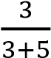 = ……………………………………………………………………………….01 mark

3 18
= …………………………………………………………………………………………01 mark 8 𝐵𝐶 3𝐵𝐶 = 8 × 18 3𝐵𝐶 8×18
= ………………………………………………………………………………….……01 mark
3 3
𝐵𝐶 = 48……………………………………………………………………………………..…….01 mark

- (a) 𝑎² + 𝑏² = 𝑐²………………………………………………………………………………….…01 mark
9² + 𝑥² = 15²
81 + 𝑥² = 225……………………………………………………………………..…….…01 mark 81 − 81 + 𝑥² = 225 − 81 = 144………………………………………………..…..01 mark
𝑥² = 144………………………………………………………………………….01 mark
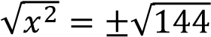
𝑥 = ±12
𝑥 = 12, 𝑥 ≥ 0…………………………………………………………….……01 mark

(b)

200

m

h

24
°
36
′

Tan 24°36^{′ = ℎ} ………………………………………………………………………….…01 mark
200
ℎ = 200 × 𝑡𝑎𝑛24°36′……………………………………………………01 mark
= 200 × 0.4578 …………………………………………………………01 mark
= 91.57 𝑚
Therefore the height of the building is about 91.57 m high. ……………..01 mark

- (a) (i). A∩ 𝐵 = 40 ……………………………………………………………………………….01 mark
  - 𝜇 = 75 + 40 + 95 + 90 ……………………………………………………………01 mark
= 300…………………………………………………………………………………..01 mark
  - A(𝐴 ∪ 𝐵)′ = 𝐴′ ∩ 𝐵′ = 90…………………………………………………….01 mark
  - 𝐴′ ∩ 𝐵 = 95………………………………………………………………………….…01 mark

(b)(i) Let upper class limit be 𝑥 Let lower class limit be 𝑦
𝑢𝑝𝑝𝑒𝑟 𝑐𝑙𝑎𝑠𝑠 𝑙𝑖𝑚𝑖𝑡+𝑙𝑜𝑤𝑒𝑟 𝑐𝑙𝑎𝑠𝑠 𝑙𝑖𝑚𝑖𝑡
Class mark=
2
𝑥
+
𝑦
22 =
2
44 = 𝑥 + 𝑦 ……………..equation 1……………………………….…..01 mark

Upper real class limit− lower real class limit = 𝑐𝑙𝑎𝑠𝑠 𝑤𝑖𝑑𝑡ℎ 𝑜𝑟 𝑐𝑙𝑎𝑠𝑠 𝑠𝑖𝑧𝑒
𝑥 + 0.5 − (𝑦 − 0.5) = 5
𝑥 − 𝑦 + 1 = 5
𝑥 − 𝑦 + 1 − 1 = 5 − 1
𝑥 − 𝑦 = 4 ……………………………………………………………..…01 mark

Solve equation 1 and 2
+|𝑥𝑥+−𝑦𝑦==444

2𝑥 = 48
2𝑥 48 =
2 2
𝑥 = 24……………………………………………………………………………………..01 mark

Substitute 24 for 𝑥 in equation 2
𝑥 − 𝑦 = 4
24 − 𝑦 = 4
24 − 4 = 𝑦 + 4 − 4
𝑦 = 20………………………………………………………………………………….01 mark

Frequency distribution table
Class interval | Tally | Frequency
15−19 | ǀǀ | 2
20−24 | ǀǀǀǀ ǀǀ | 7
25−29 | ǀǀ | 2
30−34 | ǀǀǀǀ ǀǀǀǀ | 9
35−39 | ǀǀ | 2
40−44 | ǀǀǀǀ | 5
45−49 | ǀ | 1
Total……01 mark |  | 28....02 marks

(ii) Class size or width is 5 …………………………………………………………………01 mark
Modal class is 30 − 34 …………………………………………………………….…01 mark

