THE PRESIDENT’S OFFICE
REGIONAL ADMINISTRATION AND LOCAL GOVERNMENT

BUNDA DISTRICT COUNCIL

FORM TWO PRE-NATIONAL ASSESSMENT
031 PHYSICS
MARKING SCHEME SEPTEMBER 2023

SECTION A
1.
i. | ii. | iii. | iv. | v. | vi. | vii. | viii. | ix. | x.
B | D | D | C | C | D | A | A | A | C
01@ = 10 marks
2.
List A | i. | ii. | iii. | iv. |  | v.
LIST B | D | C | A | E | F
01@ = 05 marks
SECTION B
- (a) (i) The volume of liquid displaced
      - The volume of immersed body 02@ = 06 marks
      - The density of the liquid
(b) (i) Weight of the object 01@ = 02 marks
(ii) Upthrust(buoyant force)
(c) (i) Upthrust must be equal to the weight of the body
(ii) Upthrust must be greater than weight of the body ^{01@ = 10 marks}

- (a) Archimedes’ principle states that
“When a body is totally or partially immersed in fluid, it experiences an upward force which is equal to the weight of the fluid displaced”
(02 marks)
(b) 𝑈𝑝𝑡ℎ𝑟𝑢𝑠𝑡 = 𝑤𝑒𝑖𝑔ℎ𝑡 𝑜𝑓 𝑓𝑙𝑢𝑖𝑑 𝑑𝑖𝑠𝑝𝑙𝑐𝑒𝑑
1.5 = 𝑤𝑒𝑖𝑔ℎ𝑡 𝑖𝑛 𝑎𝑖𝑟 − 3.2𝑁 03𝑚𝑎𝑟𝑘𝑠 𝑤𝑒𝑖𝑔ℎ𝑡 𝑖𝑛 𝑎𝑖𝑟 = 1.5 + 3.2 = 4.7𝑁 03 𝑚𝑎𝑟𝑘𝑠

- (a) By the process called diffusion (03 marks)
(b) After absorbing water by osmosis (02 marks)
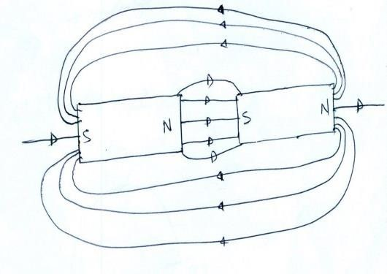
(c)
(05 marks )

- (a)Principle of moments states that
“When the system is in equilibrium then the sum of clockwise moments about a point is
equal to the sum of anticlockwise moments” (02 marks)

(b) (i) By increasing the length of a spanner (02 marks)
(ii) By increasing the magnitude of force to be applied (02 marks )

(c) (i) Stable equilibrium
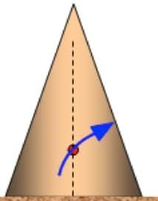

(02 marks)

(ii) Unstable equilibrium
(02 marks)
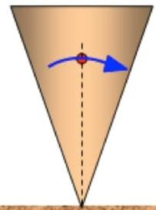

(iii) Neutral equilibrium
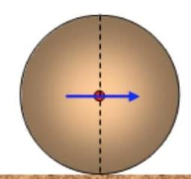
(02 marks)

- (a) A linear momentum is a product of a mass and its velocity. ( 02 marks)

(b) Force is directly proportional to the rate of change of linear momentum
(03 marks)
𝐹α(V-U)/t (03 marks)

(c) Data:
Mass (m) =50Kg
Momentum = 3000kg/s Velocity= K.E=?

(i) 𝑀𝑜𝑚𝑒𝑚𝑡𝑢𝑚 = 𝑀𝑎𝑠𝑠 × 𝑉𝑒𝑙𝑜𝑐𝑖𝑡𝑦 𝑉𝑒𝑙𝑜𝑐𝑖𝑡𝑦 = Momentum / Mass =3000/50
=60m/s (03 marks) (ii) Kinetic =1/2 × Mass × (Velocity)²

=0.5 × 50 × (60)²
=90,000J (03 marks )
- (a) (i) Lifting pump
(ii)Siphon
(iii)Syringe any two (01 mark)
(iv)Barometer
(v)Spirit level
(vi)Bicycle pump

(b) Her shoes has small surface area in contact, hence creates higher pressure on the floor
than elephant. Proved by the fact that Surface Area[A] is inversely proportional to
Pressure[P]
(04 marks)
(c) (i) Data:
Height h=2 m
Acceleration due to gravity, g= 10 N/kg

Density p=1000 kg/cm³

P =hpg
P=2m × 1000kg/m³ × 10N/kg (02 marks )
P =20000 N/m²(Pa)

(ii) Thrust = 𝑃𝑟𝑒𝑠𝑠𝑢𝑟𝑒𝑥𝐴𝑟𝑒𝑎

Area= 3𝑚 × 2𝑚 = 6m² ^{(02 marks} ⁾
Thrust= 2000𝑁/m² × 6m²
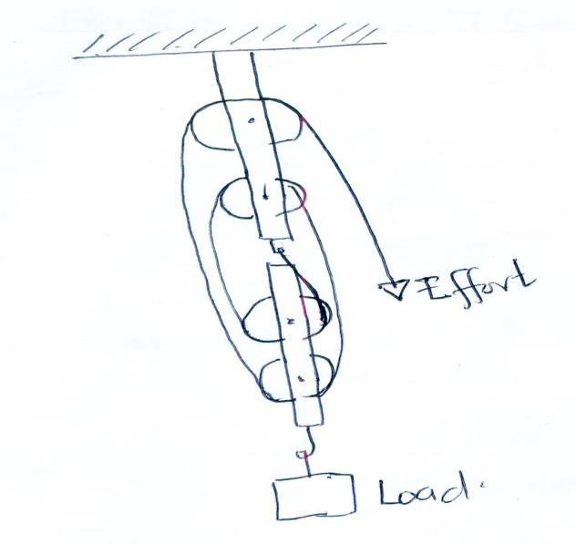
=120000N
- (a)

(04 marks)

(b) (i) Workout put = Load × Distance ₍₀₂ marks)
= 400N × 2.5m
= 1000J ^{(01 mark)}

𝑤𝑜𝑟𝑘 𝑜𝑢𝑡𝑝𝑢𝑡 ^{(01 mark)}
        - Efficiency = × 100%
𝑤𝑜𝑟𝑘 𝑖𝑛𝑝𝑢𝑡
Efficiency = 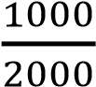 × 100% = 50% ^{(01 mark)}

        - M.A. = efficiency × V. R

= 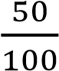 × 4 ^{(01 mark)}
 |  | M.A = 2  SECTION C | (01 mark)
10. | (a) | 3𝜇F 2𝜇F | 6𝜇F

(
05

mark)

(b) C1=3𝜇F
C2=2𝜇F 1
= + +
𝐶_{𝑇} 𝜇𝐹 𝜇𝐹 𝜇𝐹
1
=
𝐶𝑇 𝜇𝐹

1
= (05 mark)
𝐶𝑇 𝜇𝐹
𝐶_{𝑇} = 1𝜇𝐹
Q=CV=1F × 30volts = 30𝜇C
(c) Data
V=9V
I=3A Resistance R =?
(05 mark) From V=IR,
R=V/R =9/3
Resistance = 3Ώ

