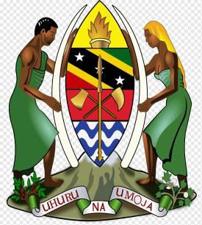

Time: 3 Hours
February, 2025
PRESIDENT’S
OFFICE
REGIONAL ADMINISTRATION AND LOCAL GOVERNMENT
TANGA, IRINGA, SINGIDA, MOROGORO, DODOMA, LINDI AND MTWARA
FORM SIX REGIONAL JOINT PRE
−
NECTA EXAMINATION
112/1

HISTORY 1
(
For Both School and Private Candidates)

Instructions
- This paper consists of seven (07) questions.
- Answer only five (5) questions. Question one (1) is compulsory.
- Each question carries twenty (20) marks.
- Cellular phones and unauthorized materials are not allowed in the examination room.
- Write your Examination Number on every page of your answer booklet(s).

Page 1 of 2

Answer five (5) questions. Question one (1) is compulsory.
- Despite the presence of Red Indians and Europeans indentured Labour in America, yet Africans were enslaved in America. Analyse the reasons, which made Europeans to prefer African dawns over other forms of Labour. (06 Points)
- Muhammad Ali, Mike Tyson, Michael Jackson and other Famous black Americans are said to be inhabitants of America. How did these People become the inhabitants of America? (Six points)
- In six points, explain the statement: “Feudal system in Africa and Europe were identi- cal.”
- “The position of Islam in West Africa States formation in the 19th C is not something easy to be ignored.” In six points with supportive examples, justify this statement.
- Political instability is a pandemic disease leading to weak health and deaths to many Africans. In six points, suggest better treatment to omit it.
- “Maganga’s grandmother, who is Zaramo by tribe, lived in America and was educated here in Africa before the imposition of colonialism.” Identify and explain six features of that education she got.
- Once Walter Rodney argued that the underdevelopment of Africa to a large extent was due to historical phenomena, although by the 5th C Africa and Europe were said to be at the same level of development. Account for the lagging behind of Africa from the 15th to the 21st C. Give out six (06) points.

Page 2 of 2

