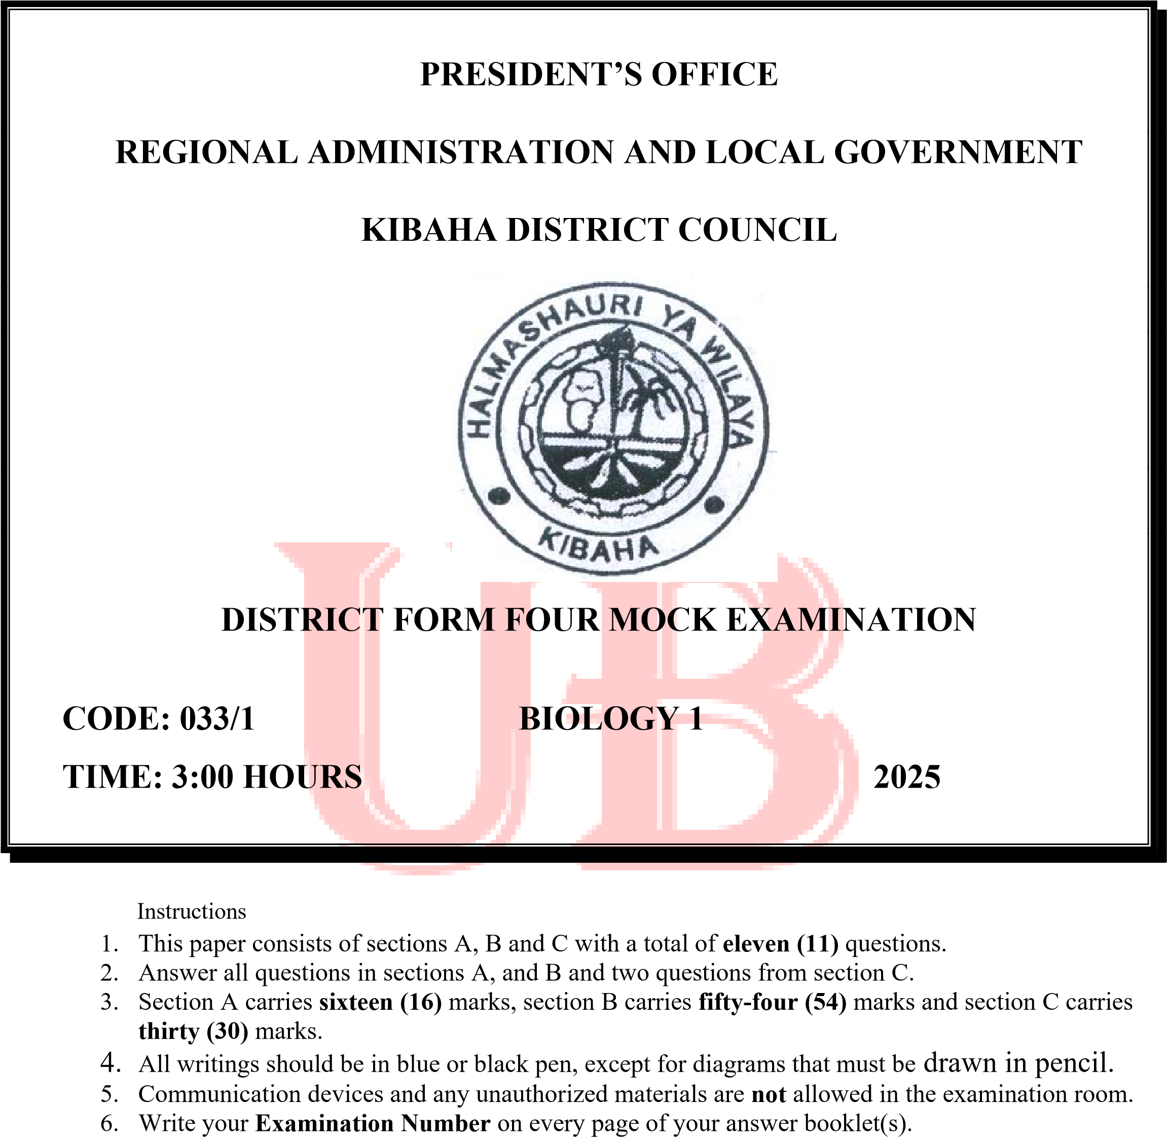

SECTION A (16 MARKS)
Answer ALL questions from this section
- For each of the items (i) - (x), choose the correct answer from among the given alternatives and write its letter beside the item number in the answer booklet provided. (i) Maintenance of constant internal environment of a body is ...............
    - Secretion
    - Osmoregulation D. Regulation
    - Homeostasis E. Peristalsis

(ii) If the human blood is mixed with distilled water and examined under microscope, the red blood cells would have:
    - Expanding D. Stayed in some size
    - Shrunk a little E. Swollen and bust
    - Swollen slightly

(iii) A biologist discovered a new cell in a culture. The new cell had district cell wall but did not have a definite nucleus. The cell is most likely to be:
    - Animal cell D. Protozoa
    - Fungi E. Eukaryote
    - Prokaryote

(iv) In which of the following mammalian blood vessel does deoxygenated blood flow away from the heart?
- Aorta  - Vena cava  - Ventricle  (v) The function of bile is to: |  | D. Pulmonary artery E. Pulmonary vein
- Soften food  - Produce gall stones  - Deaminate protein |  | - Digest fat  - Emulsify fats

  - Part of cassava plant which is modified for food storage is:
    - An underground stem D. An underground stalk
    - Underground root E. A fruit
    - A corn

  - All of these are characteristics of respiratory surfaces except:
    - Thin
    - Moist
    - Have large surface area
    - Far from an efficient transport system
    - Well supplied with blood capillaries

  - Nerve cells are interconnected by:
    - Synapse D. Axon
    - Cell body E. Myelin sheath
    - Dendrites

  - If a parent cell has twelve chromosomes, how many chromosomes will be in the daughter cells after meiosis?
    - Six (6) D. Thirty-six (36)
    - Twenty-four (24) E. Twelve (12)
    - Eight (8)
  - When a human being stretches out his or her fore arm to pick a phone from a table, the motion of the arm is brought about by:
    - Contraction of the biceps and relaxation of triceps
    - Stretching of skin and relaxation of ligaments
    - Contraction of triceps and relaxation of biceps
    - Relaxation of both biceps and triceps
    - Contraction of the flexor and extensor muscles

- Match the phrases in List A with the responses in List B by writing the letter of the correct response beside the item number in the answer booklet provided.

LIST A | LIST B
i. The type of growth that occurs in a series of stages ii. The type of growth whereby all body organs grow at the same rate  - The type of growth whereby organism stop growing when a certain body size or age is attained  - The type of growth whereby different parts of the body of an organism grow at different rates and stop growing at different times  - The type of growth whereby growth occurs all over the body of an organism  - The type of growth whereby growth occurs in certain regions of an organism | - Diffuse growth  - Localized growth  - Isometric growth  - Allometric growth  - Indeterminate growth  - Determinate growth  - Intermittent growth

SECTION B (54 MARKS) Answer ALL questions from this section
- (a) For the following situations, decide whether the muscles cells in human body are likely to be relying mainly on aerobic or anaerobic respiration to supply their energy requirements.
  - A person is running a marathon distance of twenty-seven miles over five hours.
  - A child sprints sixty meters down a hallway in nine seconds.
  - A rabbit in a garden spots a fox and immediately jumps away.
  - Describe two ways in which the body prevents food from entering the lungs.
- (a) Other than the elimination of waste products, identify other four functions of urinary system.
  - If the body is dehydrated, what do the kidneys do and what does this do to the appearance of the urine produced?

- (a) Why waste disposal is a problem in our society? Give five points
  - What can be done to reduce waste in our environment? Give four points
- (a) Discuss the process of absorption of water by root hairs. (any two point)
  - What does the circulatory system consist of? Give the main function of each component

- (a) Explain how concentration of sugar in blood is maintained constant in humans.
  - Compare the functions of parts of the mammalian eye and camera. Give five points
- (a) What are roles of decomposers in an ecosystem? Give three points
  - Give four differences between food chain and food web.

SECTION C: (30 Marks)
Answer any two (2) questions from this section.
- Discuss how the knowledge of genetics can be applied in our country. Give six points.
- Juma believe that all plants are good to human beings. You as a form four student give Juma awareness by tell him how plants are both good and bad to human beings. Give three points in each side (six points in total)
- Before Biology session on reproduction in plants, form three students at Kwala secondary school were required to collect insect-pollinated flowers from the school environment. With six points explain how you can help them to identify the flowers they required to collect.

