

Time: 3 Hours
February, 2025
PRESIDENT’S
OFFICE
REGIONAL ADMINISTRATION AND LOCAL GOVERNMENT
TANGA, IRINGA, SINGIDA, MOROGORO, DODOMA, LINDI AND MTWARA
FORM SIX REGIONAL JOINT PRE
−
NECTA EXAMINATION
113/1

GEOGRAPHY 1
(
For Both School and Private Candidates)

Instructions
- This paper consists of sections A and B with a total of seven (7) questions.
- Answer a total of five (5) questions; two (2) questions from section A and three (3) questions from section B. Question number one (1) is compulsory.
- In section A, question number one (1) carries twenty-five (25) marks and the other two carry fifteen (15) marks each, while in section B, each question carries twenty (20) marks.
- Credit will be given for the use of relevant sketch maps and diagrams.
- Map extract of HANANG (sheet 53/4) is provided.
- Non-programmable calculators may be used.
- Cellular phones and any unauthorized materials are not allowed in the examination room.
- Write your Examination Number on every page of your answer booklet(s).

SECTION A (40 Marks)
Answer two (2) questions from this section. Question one (1) is compulsory.
- Study carefully the following photograph and answer the questions that follows;

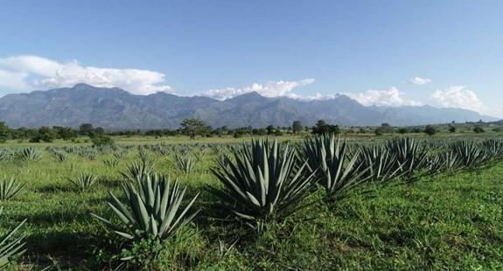
  - Giving two reasons, identify the type of photograph.
  - Outline four characteristics of the type of photograph identified.
  - With evidence, suggest two economic activities carried out in the area.
  - Name the crop shown on the photographed area.
  - Give three environmental factors that might have influenced the growth of the crop shown in the photograph.
  - Describe the relief of the area.
  - A geography teacher assigned Musa and Ally to take photographs of their home places. After submission of their assignment, it was observed that Juma’s photo- graph had higher quality compared to Ally’s photograph. Give four reasons for that variation.
  - Calculate the average scale of a vertical air photograph taken by an aircraft flying at 19,000 ft with a focal length of 6 inches. The surface has an average elevation of 100 ft.
- Mara is among the regions in Tanzania which is largely affected by family violence es- pecially women being beaten and family separation which cause school dropout to many young boys and girls. Dr. Makonde from University of Dodoma decided to conduct re- search to know the reasons behind this problem. He went to Tarime where he collected

data by asking orally some girls and boys questions concerning women being beaten and family separation
  - Identify a method of data collection used by Dr. Makonde.
  - Name and define two types of the method of data collection named in (a) above.
  - Give three merits and demerits of the method of data collection named in (a) above.
  - Dr. Makonde discovered that there is a need of doing reconnaissance research. As an expert, what are the reasons for doing so? Give three points.
- Study carefully the map extract of MBEYA, sheet 244/4 provided then answer the fol- lowing questions.
  - Using two evidences suggest the type of climate depicted on the mapped area.
  - Mr. Hamisi is a new teacher at Luanda school, he is not aware of drainage system of the area covered by a map. By using a map given, explain briefly to Mr. Hamisi about the drainage system of the area.
  - Briefly explain four factors that have influenced the population distribution on the mapped area.
  - Comment on the relief of the mapped area.
  - Identify the feature found 5Km ENE of the grid reference 432126 and state two ecological importance of it.

SECTION B (60 Marks)
Answer three (3) questions from this section

- The Earth is the only planet that sustains life. Based on this assertion, examine eight (8) positive impacts of the atmosphere on earth’s surface.
- Assume you are a community leader and you have been assigned a work to sensitize people on different farming practices that can be used to improve the fertility of the soil and hence improvement of agricultural production in Tanzania. Using eight (8) points, briefly, explain what you are going to present.
- “The occurrence and existence of underground water is affected by a number of factors”. Justify this statement by providing eight points.
- Examine eight (8) factors for the variation in the amount of insolation received on the earth’s surface.

