THE PRESIDENT’S OFFICE
REGIONAL ADMINISTRATION AND LOCAL GOVERNMENT
UKEREWE DISTRICT COUNCIL


FORM FOUR MOCK EXAMINATION
041 BASIC MATHEMATICS
TIME 3:00 Hours Year: 2025

INSTRUCTIONS

- This paper consists of section A and B with a total of fourteen (14) questions.
- Answer all questions in both sections.
- Each question in section A carries six (6) marks while each question in section B
carries ten (10) marks.
- All necessary working and answers for each question done must be shown
clearly.
- Mathematical tables and non – programmable calculators may be used.
- All communication devices and any unauthorized materials are not allowed in the examination room.
- Write your Examination Number on every page of your answer booklet (s).
- Where necessary, use the following constants:
• Pie, 𝜋= 3.14
• Radius of the Earth, 𝑅e = 6370𝑘𝑚

SECTION A (60 marks)
Answer all questions from this section
1. (a) Four bells are set to sing at the interval of 6, 3, 10 and 15minutes; if they ring together at 8:00 am, at what time will they ring together again?
(b) During the construction of the community market, a constructor set aside 27,000,000Tsh for paying 200 workers a day equally
(i) How much money did each day worker get?
(ii) How much money did the constructor remain with?

2. (a) Solve the following equations
(i) $log\sqrt{x}$ = $\sqrt{\log{x}}$
(ii) $\log{x^{2}}$ = ${(\log{x})}^{2}$
(b) Show that the sum of $\frac{1}{2 - \sqrt{3}}$and $\frac{1}{2 + \sqrt{3}}$is rational number

3. (a) Given the universal set$⋃$ has 20 elements and subset ⋃ are A and B where
n(A) =10, n(B) = 11 and n(A$∩$B) = 18, find n (A$∩$B)’
(b) In a group of students, the probability that a student is chosen at random walking to school is 0.35 and the probability that a student’s has blonde hair is 0.2. If the probability that student has blonde hair or walks to school is 0.45. Find the probability that a student has blonde hair and walks to school.

4. (a) If a point (2, 3) bisects the portion of a line AB which is cut off by the coordinates axes (figure below), find the equation of line AB
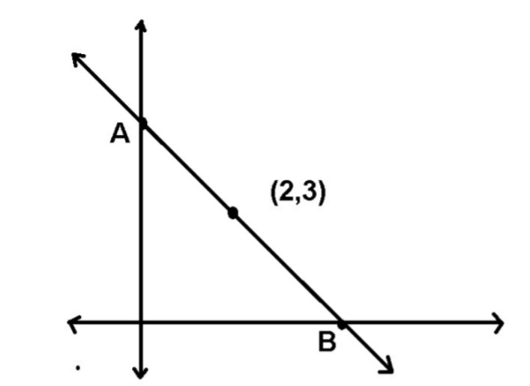
(b) Given $\underline{a}=6\underline{i}+8\underline{j}$, find the direction cosines of $\underline{a}$ and the angle that $\underline{a}$ makes with the positive x-axis

5. (a) The area of a regular 6-sided plot of a land inscribed in circular track of radius r is 720m². Find the radius of the track.
(b) Write a two columns proof for the given figure below
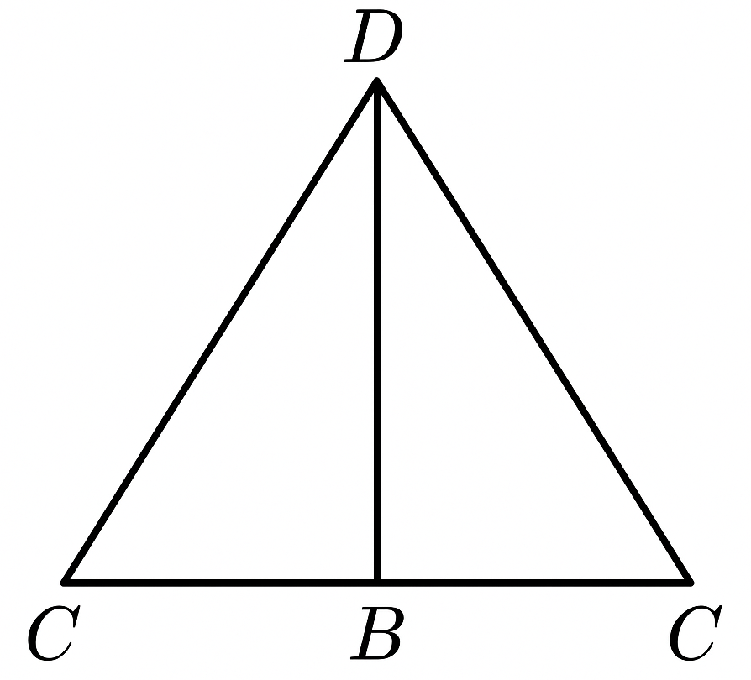

6. Nine workers work 8 hours a day to complete a piece of work in 52 days. How long will it take 13 workers to complete the same job by working 6 hours a day?

7. (a) A shirt was sold for Tsh 6650, after a reduction of 5%. What was the original price of the shirt?
(b) Prepare balance sheet as at 31st December 2005 from the following balance
Goodwill 5,000
Creditor 10,000
Cash at bank 16,000
Debtor 2,500
Cash in hand 1,500
Capital 70,000
Motor vehicle 25,000
Building 45,000
Net loss 5,000
Drawing 5,000
Loan from bank 20,000
Closing stock 5,000
8. (a) Given the sequence 3, x, y, -24, find x and y if
(i) The sequence is arithmetic
(ii) The sequence is geometric
(b) Logs are piled up in the shape of a pyramid such that there are 60 logs at the bottom row, and each row thereafter has 2 fewer logs than the row direct below it. If at the top there are only 2 logs, find the total number of logs in the bunch.

9. (a) Point X and Y lie East of a stationary kite P and are 60m apart. The angles of elevation of the kite from X and Y are 40$°$ and 35$°$ respectively. Present this information in a triangle then, find
(i) PY
(ii) The height of the kite
(b) Find the truth set of the equation $sin x^{°}=\sin{2x}$ if $0^{°} ≤x ≤ {360}^{°}$

10. (a) Find the value of Q if the expression is a perfect square 4x² + Q + 9y²
(b) Given the graph below
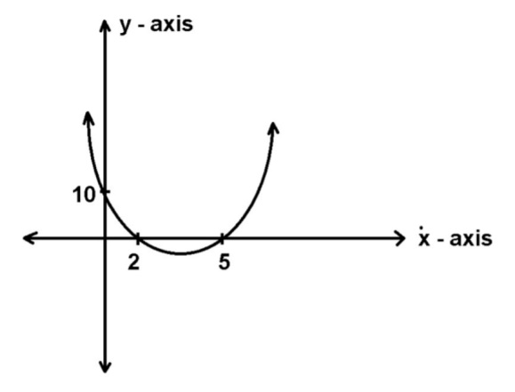
(i) What is the equation of the graph?
(ii) Factorize the quadratic equation

SECTION B (40 Marks)
Answer ALL questions from this section
11. (a) The following scores were obtained in a mathematical test of 50 students
43 60 65 80 85 50 55 40 45 70 70 50 50 55 60 45 70 65 45 50 65 48 45 60 65 80 43 55 50 65 50 82 60 40 43 45 80 50 65 44 60 44 82 70 55 50 40 55 60 50
(i) Construct frequency distribution table with classes 39 – 49, 50 – 60, 61- 71
(ii) Calculate the mean score
(b) PS and PT are tangent to the circle at T and S respectively. AT and AS are chords which intersects PS and PT at S and T. If m$<(TAS)$ = ${60}^{°}$, find m $(<TPS)$
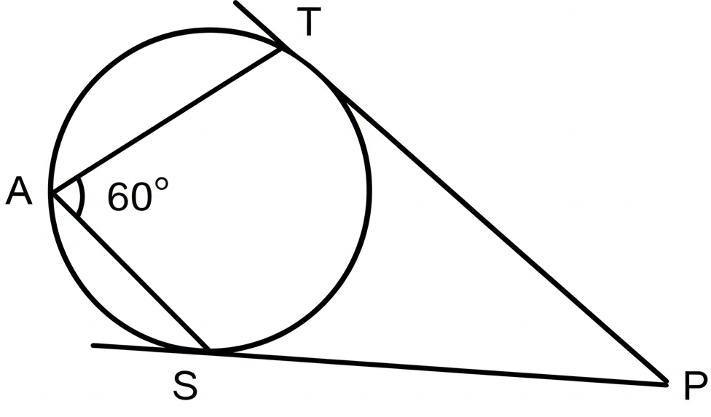

12. The following figure is a rectangular prism in which $\overline{AB}$ = 20cm, $\overline{BC}$=16cm, and $\overline{CG}=$12cm. Calculate
(i) The length AG
(ii) The angle $\overline{AG}$ makes with the plane ABCD
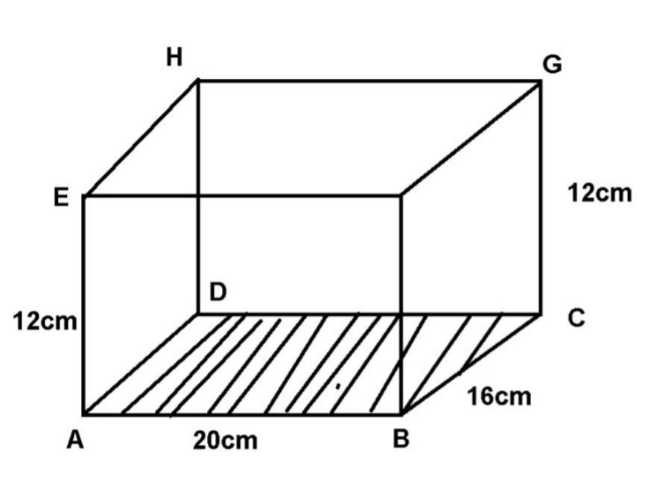
(b) An aeroplane starts at (20$°$S, 30$°E$) and flies north for 4000km. Find its new latitude and longitude. Radius of the earth R = 6370km

13. (a) Find the equation of the image of the line y = 2x – 1when reflected about the line y + x = 0
(b) The ratio of the ages of a father and his son are 8 : 3. If ten years ago, the ratio of their age was 6 : 1 find their present age

14. A function f ($x$) is defined as $f\left(x\right)=\left\{\begin{aligned}x if x < -2 \\ 2x if -2 ≤x <3 \\ x+1 if x ≥3 \end{aligned}\right.$
(a) i) Sketch the graph of f(x)
ii) Find domain and range of f(x)
(b) Given the relation R = { $\left(x, y\right):y= \frac{1}{x-1}$
Find
(i) Domain of R
(ii) Range of R
(iii) Inverse of R
(iv) Domain of R⁻¹
(v) Range of R⁻¹

